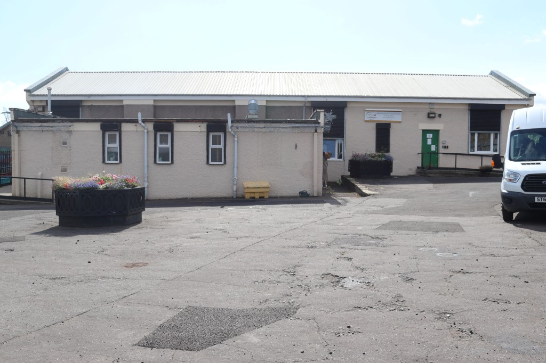

DAY AND OUTREACH SERVICE FOR
ADULTS AND OLDER PEOPLE
What we do
At Mid-Lin Day Care we strive to alleviate the
effects of Social Isolation and loneliness by
providing opportunities for social interaction in a
friendly and supportive atmosphere.
All our activities are designed to provide
stimulation and positive experiences. This can
increase confidence and an overall sense of
positive wellbeing for people who use the day
service.
Cost (Day Service)
Full Day - £45
Half Day - £26

Here is an example of our
day-to-day activities that
we offer.
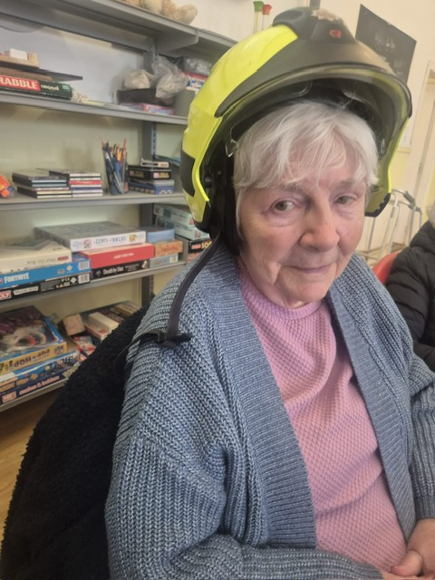

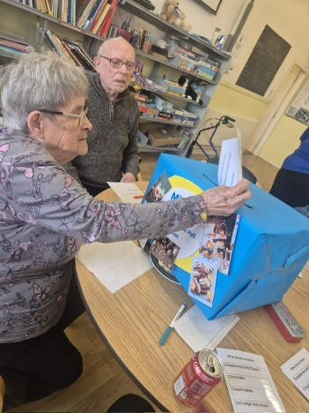

SOCIAL INTERACTION & FUN
ACTIVITIES
Quizzes and Games
Themed Days, Arts and Crafts
Bingo, Live Entertainment
Baking Corner, Reading Corner
Reminiscing and much more

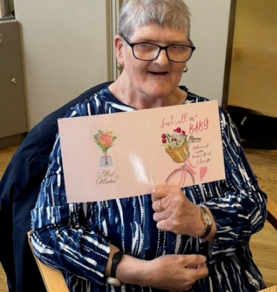
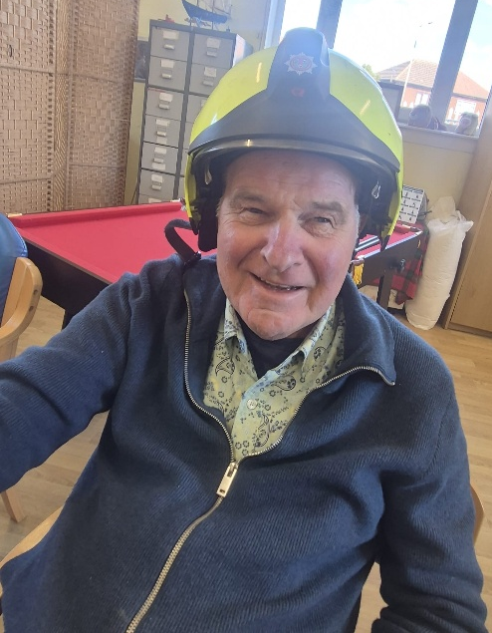

Mon | Tues | Wed | Thurs | Fri
Arts &  Crafts  Chair exercises -  Big Screen  Snooker/ Pool  Reading Corner  Tay Yukes  Bingo | Arts &  Crafts  Board  Games  Football/  Golf on big screen  Dominoes | Arts &  Crafts  Jigsaw/  Dominoes  Football Corner  Manicures  Fairmuir  Social Club  -  Community Dance | Arts & Crafts  General  Knowledge  Quiz (with prize for  best team)  Catch and Throw  Live Music with Paul O  Jenga/  Scrabble | Arts & Crafts  Carpet  Bowls /  Skittles  Darts Comp  Dominoes/ Chess  Hair and Nails  Garden  Walks
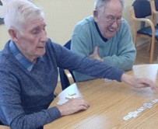
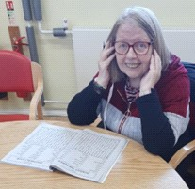
Here is an example of our 5 week Rolling Menu
Mon
Tue
Wed
Thu
Fri
Soup/Beans on Toast
Bangers & Mash
2
nd
Option
Cake & Custard
Tiramisu
Soup/Scrambled Egg
Chicken Dinner
2
nd
Option
Fruit & Custard
Trifle
Soup/Prawns
Mince & Potatoes
2
nd
Option
Rice Pudding
Cheesecake
Soup/Pate
Breaded Fish
2
nd
Option
Crumble & Custard
Jelly & Ice Cream
Soup/Bruchetta
Beef Hotpot
2
nd
Option
Fruit & Custard
Mousse
Soup/Scrambled Egg
Beef Casserole
2
nd
Option
Fruit & Custard
Viennetta
Soup/Prawns
Mini Fry Up
2
nd
Option
Rice Pudding
Tiramisu
Soup/Pate
Sweet & Sour Chicken
2
nd
Option
Crumble & Custard
Trifle
Soup/Bruchetta
Gammon Steak
2
nd
Option
Fruit & Custard
Cheesecake
Soup/Beans & Toast
Fish in Parsley Sauce
2
nd
Option
Cake & Custard
Jelly & Ice Cream
Soup/Prawns
Fish Fingers
2
nd
Option
Rice Pudding
Mousse
Soup/Pate
Beef Curry
2
nd
Option
Crumble & Custard
Viennetta
Soup/Bruchetta
Baked Potato
2
nd
Option
Fruit & Custard
Tiramisu
Soup/Beans & Toast
Chicken Casserole
2
nd
Option
Cake & Custard
Trifle
Soup/Scrambled Egg
Cottage Pie
2
nd
Option
Fruit & Custard
Cheesecake
Soup/Pate
Mince Hotpot
2
nd
Option
Crumble & Custard
Jelly & Ice Cream
Soup/Bruchetta
Fish Cakes
2
nd
Option
Fruit & Custard
Mousse
Soup/Beans & Toast
Steak Pie
2
nd
Option
Cake & Custard
Viennetta
Soup/Scrambled Egg
Lorne Sausage/Onion
2
nd
Option
Fruit & Custard
Tiramisu
Soup/Prawns
Chicken Curry
2
nd
Option
Rice Pudding
Trifle
Soup/Bruchetta
Chicken Fajitas
2
nd
Option
Fruit & Custard
Cheesecake
Soup/Beans & Toast
Shepherds Pie
2
nd
Option
Cake & Custard
Jelly & Ice Cream
Soup/Scrambled Egg
Fish Pie
2
nd
Option
Fruit & Custard
Mousse
Soup/Prawns
Beef Stew
2
nd
Option
Rice Pudding
Viennetta
Soup/Pate
Sausage Casserole
2
nd
Option
Crumble & Custard
Tiramisu
We provide a 3 course Lunch
Refreshments throughout the day
We can cater for a range of Dietary requirements
The staff are trained in
• Peg Feeding
• Stoma Care
• Administration of Medication
• Moving & Handling (We have an in-house
Trainer)
• Dementia Care
• Mental Health
• First Aid
• CPR Training
• Suicide Prevention
The full Mid-Lin team are always undergoing
various training. This is to provide essential
support to those who use our service, as well
as improving their own knowledge and
understanding.
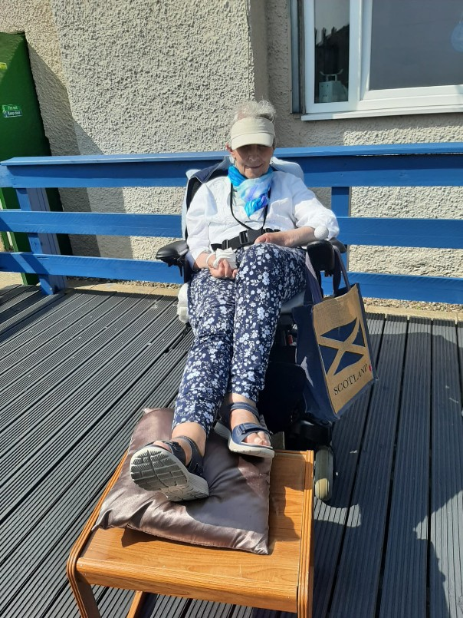
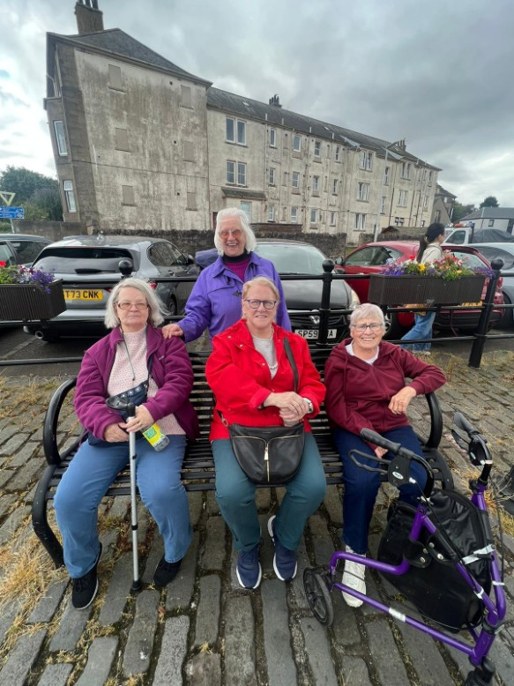
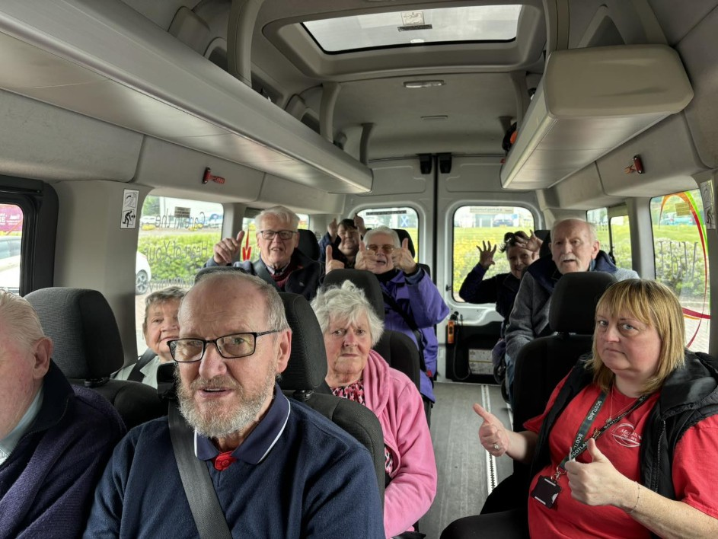

OUTREACH SERVICE
For those unable to get into the centre, we
offer personalised support, such as
shopping, as well as taking people for coffee,
lunch, walks or other outings.
Cost (Outreach Service)
Per Hour - £24

CONTACT INFORMATION

Mid-Lin Day Care Centre
59 Pitkerro Drive, Linlathen
Dundee, DD4 8AT
01382 506451
For any queries or additional information contact manager@mid-lin.co.uk
You can find out more about us
Website Facebook
www.mid-lin.co.uk www.facebook.com/midlindaycare
We are at the bottom of Pitkerro Drive, Dundee (Last building on the right)
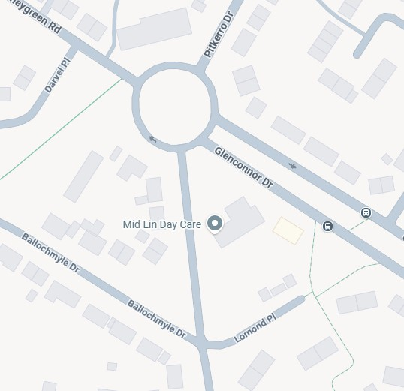

C
h
r
i
s
t
m
a
s
N
i
g
h
t
L
i
g
h
t
s

MID-LIN IN THE COMMUNITY
