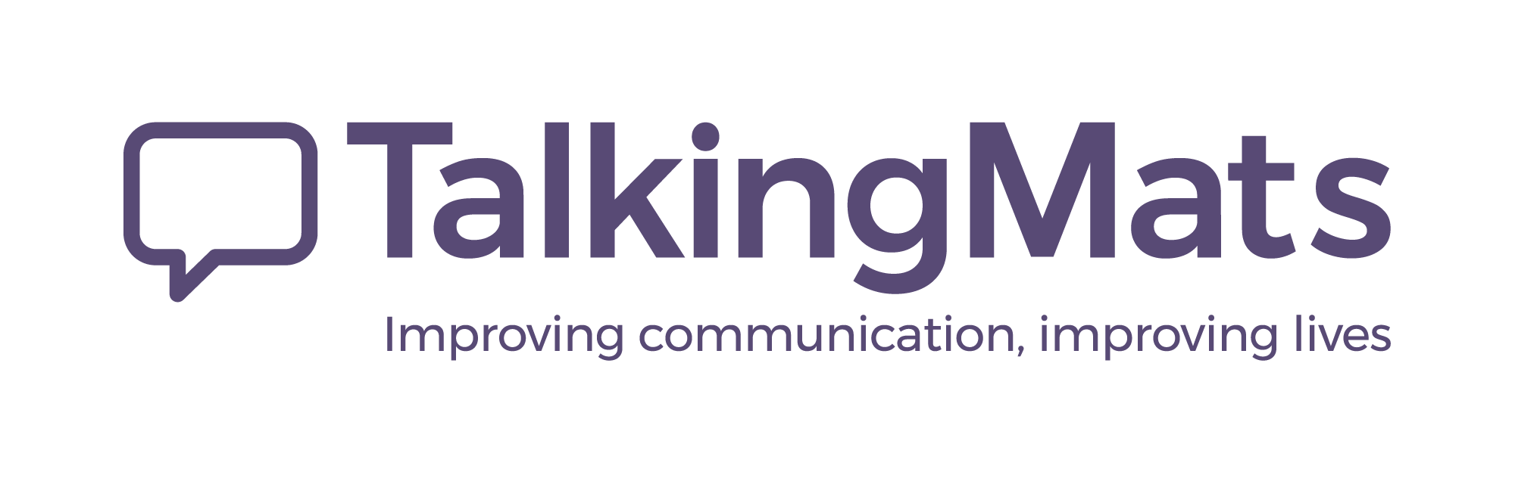

Talking Mats: Exploring Spirituality

What Is the Talking Mats Spirituality Resource?
This resource offers a gentle, yet systematic approach to exploring spirituality for those who may find this a challenge because of cognitive and or expressive difficulties. It was developed in partnership with the University of Aberdeen, Centre for Autism and Theology and involved working in partnership with people from Muslim, Sikh, Buddhist, Pagan, Christian, and Jewish faiths
There are 4 topics in the Resource
Topic | Topic | Description
 | Your Faith Community | Explore what your faith community means to you.
 | Place of Worship | Reflect on access and sensory needs in your place of worship.
 | Spiritual Practice | Designed for anyone, regardless of faith community connection, to reflect on personal spiritual practices.
 | Beliefs | Consider your core beliefs and values.

What Pilot Participants Say
"The resource structure is great, and we found that it supported the flow of the conversation well." – ‘ it’s a resource that taps into identity at a very deep level’ Feedback from pilot practitioners

Who can use this Resource?
- Faith leaders and community members
- Healthcare and social care professionals
- Anyone interested in exploring or facilitating conversations about spirituality

Book Your Place
Don’t miss this opportunity to learn more about the Resource, it’s development and practical application at our launch event.
Book here

