Creating Hope Together: Scotland’s Suicide Prevention strategy 2022-2032
Invitation for strategic partners to lead outcomes in the strategy: 15 February 2023
The strategy & action plan
In September 2022, the Scottish Government and COSLA published their new highly ambitious 10-year suicide prevention strategy Creating Hope Together and the accompanying initial 3 year action plan – 2022 to 2025.
Over the last four years, the previous suicide prevention action plan Every Life Matters delivered considerable action and learning to drive forward Scotland’s suicide prevention work. The new strategy builds on that and uses the learning to shape our approach to delivering and overseeing the new strategy and its underpinning action plan.
The Creating Hope Together vision, outcomes, guiding principles, and priority areas are summarised at Annex A.
Invitation
We are now seeking to appoint four strategic outcome lead organisations as set out further below. We consider there will be a number of benefits in taking on this key leadership role for our new national strategy including: designing and leading an innovative approach to suicide prevention; widening networks; influencing national priorities – both in suicide prevention and beyond; and actively participating in a system-wide programme of change.
Our delivery and oversight model
Creating Hope Together sets out the Scottish Government and COSLA’s plans to create a new suicide prevention delivery and advisory model.
Key elements of our approach are:
- The Scottish Government and COSLA will be accountable for delivering the strategy, and hold responsibility for aligning the strategy with wider national and local government priorities and developments. The Scottish Government will continue to set the parameters of the suicide prevention budget, and sign off the annual delivery plan with COSLA.
- Creating a new Suicide Prevention Delivery Collective with a remit to lead implementation of the national action plan by building a strong, unified and cohesive suicide prevention community across Scotland.
- Establishing a new national advisory group to oversee delivery by providing advice, advocacy and assurance on the delivery of the strategy and action plan (building on the previous National Suicide Prevention Leadership Group).
- Continuing our commitment to having lived experience and academic advice at the heart of our approach; as well as learning from what works in practice.
Of course, as with any new delivery model, we will continue to monitor the effectiveness of these new structures and ways of working and consider making adjustments where necessary.
Suicide Prevention Delivery Collective
The Delivery Collective model is intended to strengthen existing partnerships and create new ones beyond the suicide prevention community; thereby creating an active collaboration and learning approach across our national, local and sectoral suicide prevention work, helping to deepen the reach and impact of our collective work.
Further details on the delivery collective model are set out at Annex B.
Key leadership roles in the Delivery Collective
There are a number of elements which will together create the leadership platform for the Delivery Collective, this includes:
- A National Delivery Lead who will be appointed to lead the Delivery Collective and be accountable for delivering the action plan which underpins Creating Hope Together on behalf of Scottish Government and COSLA. This post will be hosted by COSLA.
- To create a broad partnership approach, strategic outcome lead organisations will be appointed to lead the delivery of each of the four outcomes in the strategy and will be accountable to the National Delivery Lead. The strategic outcome leads will select, lead and support work stream leads (who will lead on delivery of specific action/s within each of the outcomes). The four outcomes in the strategy are:
- Our environment protects against suicide
- Creating compassionate responses in our communities
- Ensuring high quality, compassionate support for anyone affected by suicide
- Enabling delivery through collective planning, evidence and learning.
Together the National Delivery Lead and the four strategic outcome lead organisations, will create a cohesive and visible leadership team for the Collective, whilst working with all partners across the Delivery Collective.

An outline of the delivery and oversight model is included below.
Delivery and oversight model: 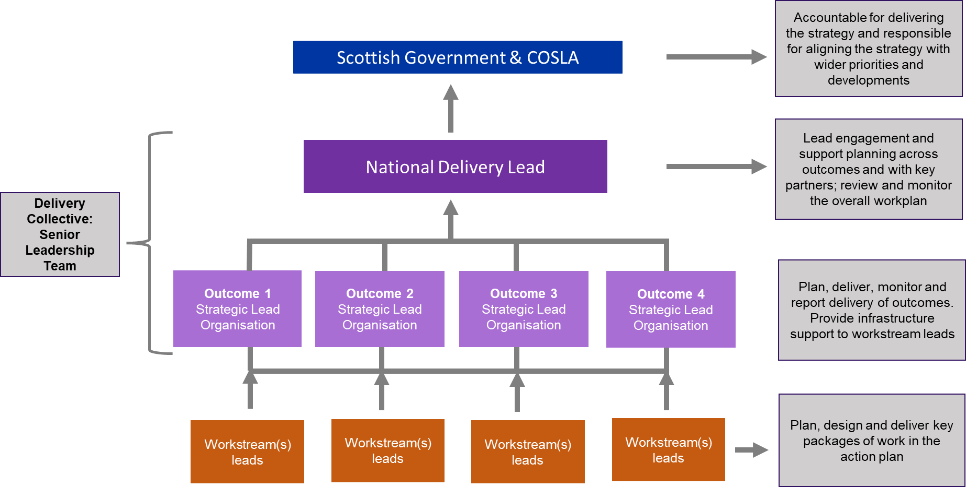

What we are looking for from strategic outcome lead organisations
Collective Leadership
- We are seeking to appoint organisations to lead on each of the four outcomes in the strategy, over the three years of the action plan (April 2023-March 2026). Along with the National Delivery Lead, they will work together as a collective to achieve the Creating Hope Together vision of reducing the number of suicide deaths in Scotland, whilst tackling the inequalities which contribute to suicide.
- Each strategic outcome lead role could be fulfilled by a single organisation, or a coalition. Where a coalition is being proposed, we would need to understand respective roles of partners, and how that model would work in practice.
- Strategic outcome lead organisations will play a central role in the new Delivery Collective, both at strategic and operational levels.
- The four strategic outcome lead organisations will work at 3 levels:
- They will form a cohesive senior leadership team to lead delivery for the action plan, alongside the new National Delivery Lead. This will involve working collaboratively across the outcomes to ensure cohesion, strategic planning (prioritisation and resourcing), innovation, and trouble shooting.
To support this cohesive leadership approach, strategic messaging and consistent identity (branding) will be in place to ensure all activities are visibly connected to the Delivery Collective and the Creating Hope Together strategy. This will be consistent internally and externally.
- Through engagement and consultation with work stream leads, and all Delivery Collective members, they will lead the planning, delivery and monitoring / reporting for their outcome. This will involve working collaboratively across outcomes, including the sharing of national delivery team resource (currently approx. 5 FTE who are employed across a range of partner organisations).
- Finally, they will provide infrastructure support for work stream leads - to support them in resource planning and achieving value for money, scoping and commissioning options, and project management expertise.
- Across the 3 levels, strategic partners will work to bring greater value and impact from each aspect of delivery under their outcome. They will seek all opportunities to work across outcomes to ensure impact is maximised, and resources are deployed effectively. They will also seek to build wider partnerships and alliances to drive change, and seek to lever in new resources.
Accountabilities
- Strategic partners will be accountable for delivery of their outcome to the National Delivery Lead, and onwards to Scottish Government and COSLA. The National Delivery Lead will provide direction on reporting.
- Strategic partners will support the National Delivery Lead in establishing and embedding the overall Delivery Collective model, including its core functions.
Early tasks for the Leadership team
Once appointed the National Delivery Lead and strategic outcome lead organisations will be asked to:
- Produce a draft annual delivery plan, for 2023/24; this will set out priorities / deliverables for year 1, including resources (which will include effective deployment of the current national delivery team resource in line with priorities and skills/ experience of staff). This process will enable the annual outcome plans to be developed in parallel; these will be signed off by the National Delivery Lead.
- Identify work stream leads for each action / cluster of actions (based on an agreed process and criteria).
Capabilities we are looking for
Essential capabilities
- Alignment of your organisation’s strategic priorities with the Creating Hope Together’s vision, guiding principles, long term outcomes and priorities. This includes: equalities sitting at the centre of your strategic and operational approach, and your ability to confidently engage and use a range of insights and evidence (including lived experience, academic research, and learning from practice).
- Experience of playing a strategic delivery role with accountability to another partner/ board. This includes: managing and prioritising action to achieve agreed outcomes, resource planning, building alliances, seizing opportunities, managing risk, and monitoring/reporting on delivery.
- Experience of leading change through cross-sector partnerships by showing collaborative leadership, creating conditions for other partners to contribute, and building new alliances which lever in new capabilities and resources.
- Organisational infrastructure and guidance (including systems, processes and people management) to support delivery and monitoring/reporting of workstream activity. This includes activity and resource planning, budget management, guidance on commissioning options, and monitoring/reporting capability. Support and advice on procurement.
- Readiness to fulfil role, from April 2023 for 3 financial years (please see pages 7 & 8 below for details of budget roles and responsibilities).
Desirable capabilities
- Suicide prevention expertise, or relevant experience in designing and delivering strategic change programmes for vulnerable groups.
Outcome specific capabilities
In addition to the above capabilities, each outcome requires a specific set of capabilities as detailed below.
Outcome 1
- Understanding of how social policy is developed and implemented.
- Pragmatism and can-do attitude to implement practical solutions on structural/societal challenges and on regulatory issues.
- Can build trust and self-awareness across partners to support cross sector suicide prevention activities.
Outcome 2
- Able to develop and deliver strategic and targeted approaches, which recognise existing assets and approaches, whilst exploring new and innovative approaches. This is likely to involve pivoting approaches, for example, to focus on new groups, settings and approaches, in order to achieve maximum impact.
- Can develop new strategic relationships to support work in new sectors and settings, to drive improved responses and collaborations.
Outcome 3
- Able to develop and deliver strategic and targeted approaches, which recognise existing assets and approaches whilst exploring new and innovative approaches. This is likely to involve pivoting approaches, for example, to focus on new groups, settings and approaches, in order to achieve maximum impact.
- Can develop new strategic relationships to support work in new sectors and settings, including clinical environment, to drive service improvements.
- Able to build understand and develop effective approaches to support people affected by suicide in any way - this is an extension to Scotland’s approach to suicide prevention.
Outcome 4
- Able to facilitate partners to create coordinated plans, spanning sectors and the life course.
- Able to design, deliver and lead enabling activities in a flexible way to meet the needs of partners and achieve positive outcomes.
- In depth understanding and value for lived experience engagement.
- Able to work with a range of partners to understand and scope data requirements, and hold the technical expertise to improve datasets and evidence, including creating new data sources and linking data.
- Able to support partners and practitioners to use all evidence to drive action and learning - at a strategic and operational level.
- Excellent communication and dissemination skills to support knowledge into action.
Note on outcome 4: We recognise there may be overlap in the role of the strategic outcome lead for outcome 4 and some core functions (please see Annex B for details of core functions). We therefore invite any organisation bidding to be the strategic outcome lead for outcome 4 to highlight if they would also wish to offer any core function roles (and to specify which ones).

Budget roles & responsibilities
The overall level of the suicide prevention budget will be determined by the Scottish Government as part of mental health funding approved by the Scottish Parliament and in accordance with Programme for Government commitments.
We recognise resource needs will vary for each outcome due to the level of prioritised activity, both human resource and direct delivery costs. In recognition of this, the National Delivery Lead and four strategic outcomes lead organisations will together shape the content of the budget for each financial year as part of the annual delivery planning exercise, in consultation with the wider Delivery Collective. The National Delivery Lead and strategic outcome lead organisations will do so within the parameters set by Scottish Government expenditure and financial protocols whilst seeking to lever in additional resources to support delivery of the national plan, where objectives align.
The draft annual delivery plan will identify priorities in each of the outcome areas (some may be overlapping), as well as the resource needed to deliver those. The draft annual delivery plan, with accompanying resource plan, will be submitted to the Scottish Government and COSLA for approval before the start of each financial year.
Overall budget accountability will sit with the National Delivery Lead, reporting to the Scottish Government. However, once the overall annual budget allocation is agreed, the strategic outcome lead organisations will oversee the budget for their outcome, in line with the Scottish Public Finance Manual (this includes ensuring clear deliverables/ monitoring, following procurement guidelines, paying only for incurred expenditure and securing value for money).
Suicide prevention budget
The budget is used to pay for a number of aspects of suicide prevention work, namely:
- Staffing costs – national delivery team and local implementation / learning leads.
- Core functions, including strategic communications.
- Ongoing research commitments, including to Healthcare Quality Improvement Partnership.
Once the above elements are accommodated, funds will be made available to the National Delivery Lead and strategic outcomes lead organisations for delivery of the action plan. They will be asked to strategically plan resource to achieve maximum impact across the action plan, and also to use the resource to lever additional funding where possible.
Anticipated annual funds to directly fund delivery of the action plan (dependent upon Scottish Government budget availability)
2023/24: £0.95m (provisional) plus £0.75m committed for activities which directly support outcomes.
2024/25: £1.65m (provisional) plus £0.15m committed for activities which directly support outcomes.
2025/26: £1.85m (provisional) plus £0.10m committed for activities which directly support outcomes.
Recognising the capacity needed to fulfil their leadership and accountability role, as well as the costs of providing infrastructure and support for workstreams, strategic outcomes lead organisations will be funded for these activities. Funding will be relative to the scale and nature of the work streams they are leading. In submitting a bid, we ask that you provide indicative costs.
We anticipate the indicative budget split across the four outcomes will be in the region of:
Outcome 1 – 10-15%
Outcome 2 – 25-30%
Outcome 3 – 30-35%
Outcome 4 – 15-20%
Where strategic outcome leads require to enter competitive commissioning processes to support delivery, then contracts will be held by Scottish Government. For all contracts, clear governance will be put in place to ensure the Scottish Government/outcomes lead, and work stream (which may include a delivery lead), are clear on their respective roles and responsibilities in relation to the service, and managing the contract.

Applying to be a strategic outcome lead
- Initial expressions of interest in applying: We would be grateful if you let us know if you are intending to submit an application by close of play 28 February 2023.
- Deadline for applications: Please submit your application by 5pm on 10 March 2023 to the Suicide Prevention mailbox: contact@suicidepreventionengagement.scot
- Format for applications: Please submit your evidence using the evidence form attached, with a maximum of 250 words per entry.
- If you have any questions or would like to discuss this invitation further, please contact either Morag Williamson morag.williamson@gov.scot or Haylis Smith haylis@cosla.gov.uk.
- The selection process will be through:
- Assessment of bids against weighted criteria by the Scottish Government/COSLA, with lived experience input
- Further information may be sought
- Interview of shortlisted candidates (provisionally weeks commencing 20 & 27 March 2023)
- Appointment of strategic outcome leads
- Feedback to all candidates.

ANNEX A
CREATING HOPE TOGETHER: VISION, GUIDING PRINCIPLES, OUTCOMES & PRIORITIES
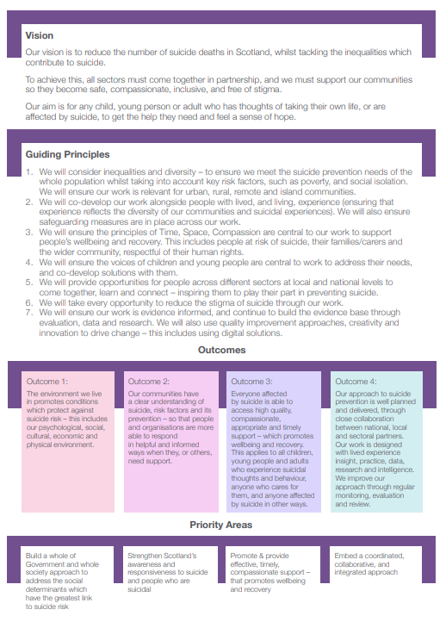
ANNEX B

ADDITIONAL INFORMATION ABOUT DELIVERY COLLECTIVE
Membership of the Delivery Collective
In Scotland, we place great value on the level of experience and maturity across our national suicide prevention community and national partners. Our new Delivery Collective is designed to facilitate a greater level of shared ownership and collaboration for delivering the strategy with these organisations.
Additionally, we know that to tackle suicide we must also focus on the range of factors and social determinants which cause suicide. As such, we will take a very inclusive approach to our membership. In taking this approach, we expect our ability to achieve our suicide prevention outcomes will be enhanced, and wider outcomes achieved.
Membership is likely to include:
National Delivery Lead
Strategic Outcome Leads
Suicide prevention partners / networks
- Suicide prevention national delivery team
- Suicide prevention implementation and learning leads (based Public Health Scotland)
- Suicide prevention local leads
- Community development/ support organisations, networks and groups (e.g. TSIs / Corra/Inspiring Scotland)
- Suicide prevention learning network
- Suicide prevention 3rd sector organisations
- First /emergency responders
- Statutory partners/ networks
- Academics
- Lived Experience panel/s
- 3rd sector organisations working to support priority groups, such as LGBT+; autism; learning disabilities; gypsy travellers, etc.
Partners working in areas which impact on suicide, including:
- poverty
- debt
- addictions
- homelessness
- trauma
- social isolation
Business community

Arrangements to support delivery of actions (work streams and core functions)
It is anticipated that each outcome will create a number of work streams to take forward day to day delivery of specific action(s) in the action plan, recognising that these will be phased and prioritised over the three years of the action plan.
Given the interconnectedness of the strategy, we anticipate some work streams may include a number of actions and will support more than one outcome. It will therefore be essential for strategic outcome leads to be proactive in facilitating cross-outcome working, to build cohesion of approach and resourcing across related and overlapping areas of work.
The Delivery Collective will host a number of core functions which will be available to each of the strategic outcome partners, and work streams. These are likely to include:
- Outcomes planning and evaluation
- Monitoring / reporting
- Strategic communications
- Internal communications, and
- Engagement with lived experience and academics.
Each of the strategic outcome partners will have the opportunity to shape the core function offer. We recognise there may be overlap in the role of the strategic outcome role for outcome 4 and some core functions (listed above). We therefore invite any organisation bidding to be the strategic outcome lead for outcome 4 to highlight if they would also wish to offer any core function roles (and to specify which ones).

