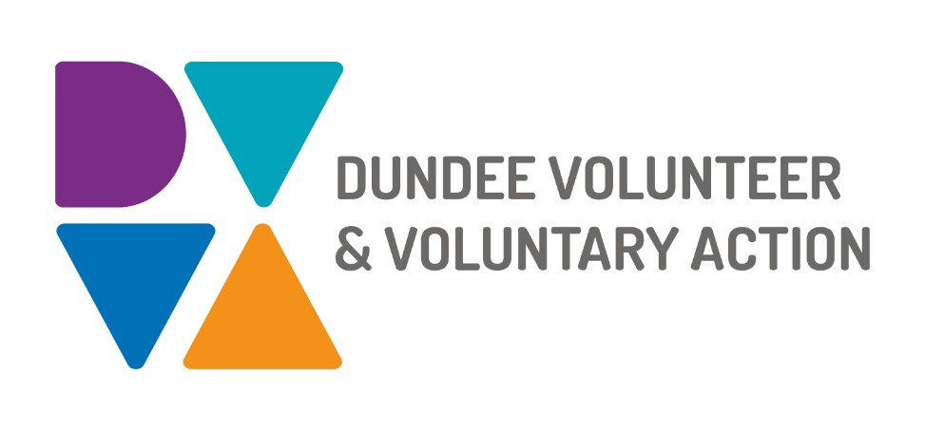

**Dundee Volunteer and Voluntary Action is looking for new trustees to support our organisation to grow and develop.**

DVVA is an independent charity that aims to ensure the third sector (like charities, social enterprises, community and voluntary groups) is robust, resilient and delivers high quality services for the people of Dundee.

**Dundee Volunteer and Voluntary Action vision:**

Supporting and empowering individuals and organisations to make positive change in their lives and their communities.

We will do this by;

* Using an evidence-based approach to enable and assist individuals and communities to create positive and long-lasting change
* Amplifying the voices of under-represented groups and communities through meaningful participation, engagement and representation
* Ensuring a strong third sector voice at a strategic level within local planning structures and nationally
* Promoting and supporting voluntary and community action
* Promoting and supporting volunteering
* Providing holistic wellbeing support to individuals, communities and organisations to create a fairer Dundee
* Promoting good governance across third sector organisations
* Supporting and developing our staff to maximise their effectiveness

**See Role Description for more information.**

**Recruitment:**

The Board is currently made up of six members and meets every two months and is looking to recruit two new members.

All applications are welcome, and we would particularly welcome those with skills or a background in a legal, or corporate setting to fill one of our vacancies. Also, we would like to strengthen the Board’s expertise in information and communication technologies, and in marketing.

If you would like to find out more or to have an informal chat with one of our existing Board members, email **recruitment@dvva.scot**  
To apply, please send your CV along with a short covering letter to **recruitment@dvva.scot** by Friday 31st October 2025.