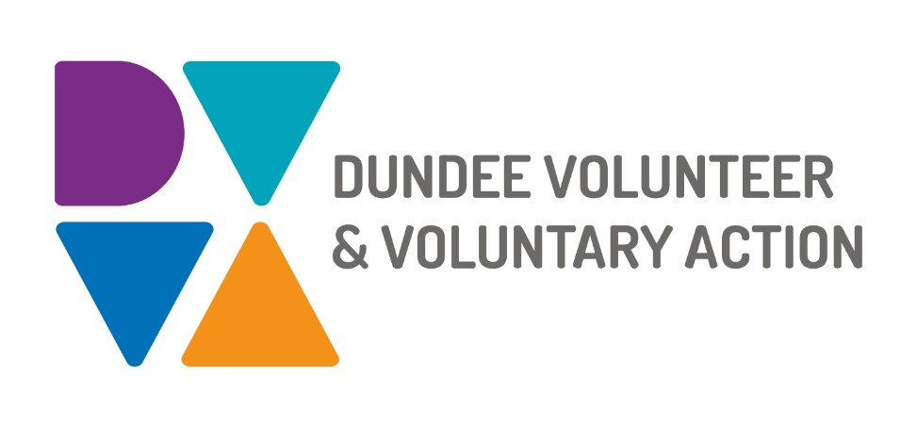

**Role Description: Trustee for Dundee Volunteer and Voluntary Action (DVVA)**

**Organisation Overview**

Dundee Volunteer and Voluntary Action (DVVA) is an independent charity and a key partner in the Third Sector Interface (TSI) for Dundee. Our mission is to ensure a robust, resilient, and vibrant third sector (charities, social enterprises, community, and voluntary groups) that delivers high-quality services to the people of Dundee. We provide support in governance, funding, legislation, policy, planning, and problem-solving, fostering community engagement and reducing social isolation to improve health and wellbeing across Dundee.

**Role Purpose**

As a Trustee, you will play a vital role in guiding DVVA’s strategic direction, ensuring good governance, and supporting the organisation’s mission to empower and strengthen the third sector in Dundee. Trustees work collectively to oversee DVVA’s activities, ensure legal and financial compliance, and champion the organisation’s values of social justice, health, sustainability, and inclusivity.

**Key Responsibilities**

1. **Strategic Leadership**

* Contribute to the development and implementation of DVVA’s strategic vision and goals, ensuring alignment with our mission to support a vibrant third sector
* Participate in setting organisational policies and priorities to address community needs, such as reducing social isolation and promoting wellbeing

**2. Governance and Compliance**

* Ensure DVVA complies with its governing document, charity law, and regulations set by the Office of the Scottish Charity Regulator (OSCR)
* Oversee financial performance, ensuring resources are managed effectively and sustainably
* Monitor and evaluate the organisation’s activities to ensure they meet charitable objectives and deliver impactful outcomes

**3. Decision-Making and Oversight**

* Attend and actively contribute to Board meetings (typically 6 per year), annual general meetings (AGM), and occasional strategic planning sessions
* Review reports, financial statements, and performance metrics to make informed decisions
* Support the Senior Leadership Team, including the CEO, in delivering the organisation’s objectives

**4. Advocacy and Representation**

* Act as an ambassador for DVVA, promoting its work and values within the community and among stakeholders
* Build relationships with third sector partners, local authorities, and other organisations to enhance DVVA’s impact and influence

**5. Risk Management**

* Identify and mitigate risks to DVVA’s operations, reputation, and finances.
* Ensure safeguarding policies and best practices are upheld, particularly in programmes involving vulnerable groups

**Skills and Qualities**

* **Commitment to DVVA’s Mission:** Passion for supporting the third sector and improving community wellbeing in Dundee
* **Diverse Perspectives:** We welcome individuals from all backgrounds, with professional or lived experience in areas such as governance, finance, HR, community engagement, or public health. Lived experience as a member of a specific community or as a service user is equally valued
* **Collaborative Approach:** Ability to work as part of a team, sharing responsibility for collective decisions
* **Analytical and Strategic Thinking:** Comfortable reviewing financial and performance data to inform decision-making
* **Communication Skills:** Able to engage with diverse stakeholders and represent DVVA effectively

**Time Commitment**

* Attend the AGM and approximately 6 Board meetings per year (some in-person in Dundee, some virtual)
* Participate in occasional sub-committee meetings, strategic planning sessions, training or events
* Estimated time commitment: 4–6 hours per month, with flexibility depending on the role and sub-committee involvement

**Desirable Experience** (not mandatory)

* Knowledge of charity governance, financial management, legal background, communication, information technology or fundraising
* Experience in the third sector, community development, or volunteering
* Understanding of Dundee’s local community and its challenges

**Eligibility**

* Trustees must be at least 18 years old and not disqualified from acting as a charity trustee under the Charities and Trustee Investment (Scotland) Act 2005.
* No specific qualifications are required, but a commitment to learning and development is desirable

**Support and Development**

* DVVA provides induction and ongoing training to support trustees in their roles, including access to resources from OSCR, Volunteer Scotland, and other governance bodies
* Opportunities to develop skills in governance, leadership, and strategic planning

**Why Join DVVA as a Trustee?**

Being a Trustee for DVVA offers a rewarding opportunity to make a tangible difference in Dundee’s communities, support a vibrant third sector, and develop valuable skills. You’ll work alongside a diverse, passionate board and contribute to a socially just, healthy, and sustainable Dundee.

DVVA is committed to diversity and inclusion. We particularly encourage applications from individuals with lived experience, underrepresented groups, and those with a passion for community impact. No prior trustee experience is required—just a desire to contribute to our mission.

**How to Apply**

To express interest in becoming a Trustee, please send your CV along with a short covering letter to **recruitment@dvva.scot** by **Friday 31st October 2025.** You may be asked to attend an informal discussion with the Chair or other Board members.

If you would like to find out more please visit [www.dvva.scot](http://www.dvva.scot) or contact us at **recruitment@dvva.scot**