REGIME PRINCIPLES
STRATEGY & STAKEHOLDER ENGAGEMENT DIRECTORATE

March

REGIME PRINCIPLES
New Model of Custody for Women

STRATEGY & STAKEHOLDER ENGAGEMENT DIRECTORATE
July 2019

Contents

- Introduction
- Background
- Strategic Outcome – Standards
- Female Estate Profile
- Core Principles of Trauma Informed Care
- Stakeholder Engagement

New Model of Custody for Women
1. Introduction
The Scottish Prison Service (SPS) Strategy for Women in Custody supports key priorities within the National Strategy – Justice in Scotland: Vision and Priorities (Scottish Government, 2017).
To underpin the strategy, this document describes a new model of custody for women and defines the approaches taken by the SPS, Stakeholders and Partners in realising positive outcomes for women in our care.
2. Background
Scottish Government and the SPS continue to recognise the vital role of our Partners and the need to continue to make transitions into and out of custody more cogent, to share information and work together to realise the best possible outcomes for women.
To achieve this, the SPS in consultation with key Stakeholders and Partners has redesigned custodial arrangements for women to ensure both the physical environment and available services are gender specific and trauma informed, meeting the needs of the women in our care. This will include delivery of a new Women’s National Facility (WNF) and Community Custody Units (CCUs).
3. Strategic Outcome - Standards
The key objective is to maximise the SPS contribution to the Scottish Government’s commitment to reduce reoffending. The SPS is committed to playing a full part in ensuring that fewer women return to custody. It intends to do this by working with statutory and third sector partners to build a collaborative, multi-disciplinary approach that will best serve the needs of women in custody.
The New Model of Custody will ensure there are opportunities for women to express and explore the life circumstances and/or choices which have led them to be in custody and will provide a range of evidence based interventions aimed at maximising the opportunity for reflection, reparation and rehabilitation. An important element will be creating an environment and conditions which are based on safety, respect and dignity. Fundamental to this will be the acquisition of coping strategies which promote behavioural change and desistance.
To achieve this, the SPS has re-designed the custodial environment with the aim of creating gender specific, trauma-informed settings where all who work, live and visit prison feel safe, respected and valued. Regime principles have been developed which will be embedded within operational practice across the women’s estate. Via the design of the new WNF and CCUs, SPS has ensured that the environment will support physical and mental health & emotional and spiritual well-being to reduce the impact and associated risk of institutionalisation. Key aspects of the bespoke facilities will encompass activities to promote independence and life skills which are gender specific and designed to reduce stress.

4. Female Estate Profile
The new model of custody will be adopted across the women’s estate which encompasses:
Assessment Centre in both the WNF and HMP & YOI Grampian
The Assessment Centre within the Women’s National Facility and the Regional Unit at HMP & YOI Grampian (for those women located in the North East of Scotland), will provide accommodation for convicted women entering custody to allow for a period of initial assessment.
An initial assessment to identify immediate needs, followed by the development of a support plan will be carried out by SPS staff with input from key stakeholders. Support plans will be tailored specifically to the needs and goals of each individual.
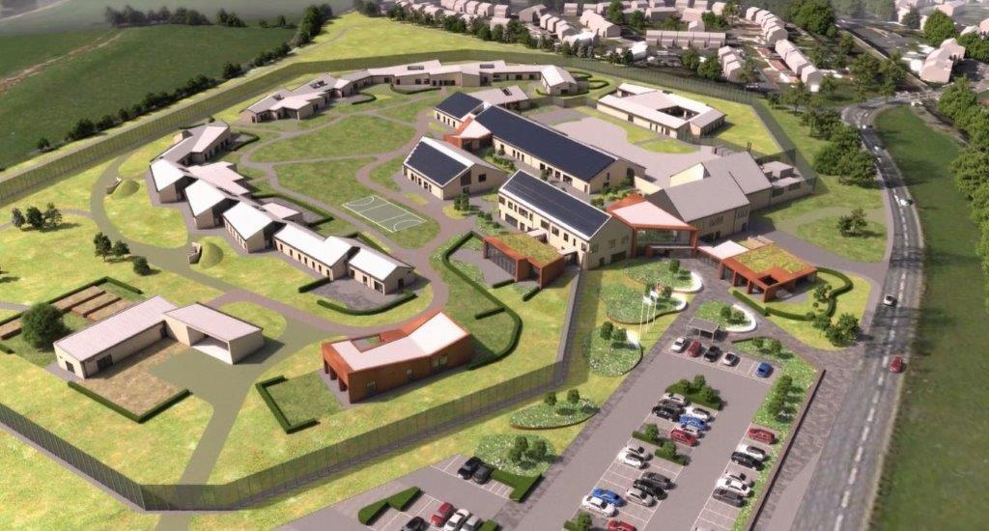
Women’s National Facility (artist Impression)
Women’s National Facility
The purpose of the WNF is to provide a safe and secure environment for women in custody who present a significant risk to the public and/or have the most complex needs.
The aim of the WNF is to promote a trusting, respectful culture with rehabilitation at its core. It should comprise care, compassion, stability, safety, physical and mental well-being, legal rights, moral responsibilities and pro-social opportunities.
The WNF offers a bespoke facility with small distinct accommodation areas, with the flexibility to accommodate the needs of all adult and young women. The facility includes: an enhanced needs area to support those women requiring more intensive mental health support; a Separation and Reintegration Unit (SRU), Progression Unit, Mother and Baby Unit and an Assessment Centre.
Evidence-based research indicates that smaller accommodation areas are desirable and more effective in achieving better outcomes for women. Therefore, the environment is designed to encourage and support transformational change, by adopting a trauma informed approach which takes account of gender. Aesthetically pleasing, the WNF fits with its natural surroundings, designed in such a way to reduce traditional institutional approaches. Design elements include: co-location of services; the use of a campus system layout; natural lighting and no bars on the windows.
Women will have the ability to develop and enhance social and family connectivity via in-room communications. Similarly, visiting areas with associated outdoor space has been designed to reduce the custodial feel and be more reflective of family life.
The inclusion of a central dining room will provide a more realistic dining experience with elements of dynamic choice within the menu. With the introduction of kitchen facilities within accommodation areas, this will encourage women to develop new skills to support independence in the preparation of meals and snacks, with support from staff.
To support the “safe space” principle, the introduction of a retreat space will allow women to access relevant support and counselling services in a safe, private and dignified environment. Furthermore, the inclusion of the garden area will allow a more personal and holistic approach to be undertaken.
Appropriate transfer progression pathways for women will be overseen by the WNF and a coordinated case management system will be in place to ensure that each individual woman is located in the right place at the right time.
Community Custody Units
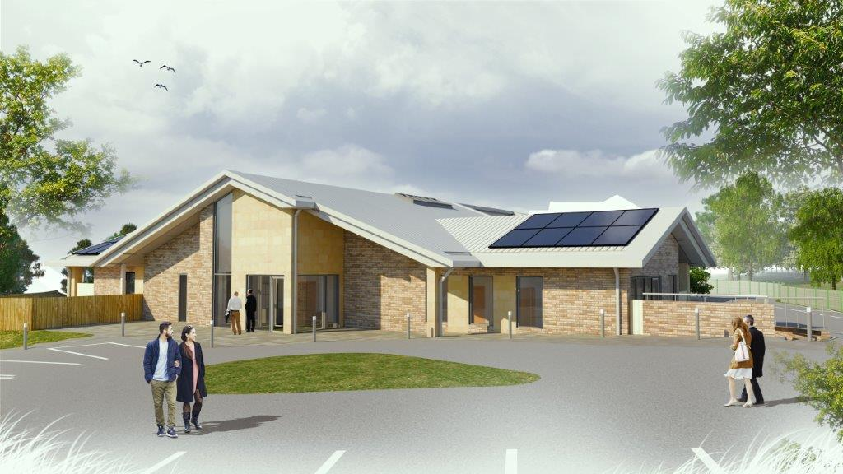
Community Custody Unit in Dundee (artist Impression)
The purpose of the Community Custody Units (CCU) is to provide safe accommodation and to support the needs of women who will benefit from closer community contact and access to local services, to create and sustain independence in preparation for successful reintegration into the community.
The aim of the CCU is to become an integral part of the community where people treat each other with respect and to reinstate and rebuild citizenship for those returning to the community.
Evidence-based research supports the need to adopt a gender specific, trauma informed approach which meets the needs of women. Small accommodation units (24 located in Maryhill, Glasgow and 16 located in Dundee) have been designed to support the specific needs of women who are assessed as suitable to transfer to a CCU, including those who would benefit from being closer to their local community.
Women will have the opportunity and will take responsibility for accessing in-reach and outreach services in order to develop a range of skills required for successful reintegration into the community as responsible citizens.
Women will be supported to live independently in accommodation based on a ‘shared house’ principle to develop a range of independent living skills which are reflective of real life. This will include the ability to plan, budget and cook a nutritionally balanced meal for themselves, shopping and preparing food for the week. Each woman will take responsibility for personal care, laundry and housekeeping within each accommodation area.
The regime will provide a range of opportunities to encourage individual choice, support self-management and develop independence. Consequently, women will be actively involved in the formulation of their time in custody and will be encouraged to engage in case management with their personal officer and service providers to sustain their support plans.
Emphasising the importance of family and social engagement, women will be encouraged to further develop social and family engagement within the CCU providing a supportive community atmosphere which will assist in enables reintegration into the community.
The community hub within both CCUs will offer visits in a central area where women can choose to meet with visitors. A range of activities and social interactions within the community hub will be incorporated including: cooking for or with a child or family member in the Saturday kitchen; children’s homework classes; engaging in family IT activities as well as the ability to interact in the outdoor space. Stakeholders and partners will be crucial to the development of the regime within the CCU and the women’s support plan to identify the activities which will support their time in the CCU and their reintegration into community life. A key element will be in supporting women to make their own choices regarding their therapeutic and rehabilitative plans.
Regional Unit at HMP & YOI Grampian
The Regional Unit at HMP & YOI Grampian will operate in alignment with the Women’s National Facility providing a safe and secure environment for women in custody, who primarily come from the North East of Scotland and surrounding areas, so as to maintain community links and provide opportunities for more independent living.
The Regional Unit accommodates single occupancy accommodation for up to 47 women, with a designated area for the management of Young People, adult women, a community integration unit, safer room provision and an SRU facility.
Women Located in Other Establishments
Women located in other parts of the SPS estate will live within safe and secure environments which as far as reasonably practicable will be close to their communities; facilitating better access to family contact and local services. The identified regime principles will be applied to ensure consistency of opportunities across the women’s estate.

5. Core Values & Principles of Trauma Informed Care
A trauma informed care approach will underpin operational practice and be embedded within the following core values to reduce the potential for re-traumatisation; whilst seeking to ensure that women in our care engage with the appropriate services, within a supportive environment.
Core Values
Trauma affects how people think, feel and behave, a greater understanding of these effects makes it easier to interact with individuals in SPS care in ways that encourage cooperation and participation in their own rehabilitation.

Safety - Women who have suffered some type of physical or emotional trauma are often hyper-aware of possible danger

Choice - When individual choice is taken away, individuals may believe their ideas and wishes are of no importance.

Empowerment - Develop and encourage self-efficacy by teaching and supporting skills.

Collaboration - Two way communication, where mutually agreed decisions and plans are implement.

Trustworthiness - Survivors of trauma may find it difficult to trust others.

Six Guiding Principles for Gender Responsive Practices
Being trauma informed means creating an environment through site selection, staff selection, programme, content, and materials that’s reflects an understanding of realities, of the lives of women, and addresses and responds to their strengths and challenges.
Relationships – Embed policy, practice which promote healthy connections family & community

Gender - Acknowledge that everyone is unique.

Community - Establish a comprehensive and collaborative network of community services.

Environment - Create an environment based on safety, respect and dignity.

Socioeconomic Status - Provide women with opportunities to improve their socio-economic conditions.

Services & Supervision – Support women to address substance use, trauma and mental health issues through integrated services and supervision.

6. Stakeholder Engagement

The SPS will work collaboratively with identified stakeholders to develop and establish a new model of managing women within the Scottish Prison Service; recognising the need for communities and services to be in place in order to support and enhance the skills and attributes of women that will assist them in their desistance journey and reintegration plans.

Structure of Approach

Stage 1 – Analysis

Understanding the “need” is a crucial first step. Need will be considered in a number of ways including, women’s needs, demand of the services in achieving both the in-reach and out-reach services required, multiple and complex needs, equality and diversity needs alongside the barriers to accessing services. This will provide an overview of the main needs of the population whilst still operating a person centred, gender specific assessment, working with women to identify their goals and aspirations for the future. Ensuring sufficient attention is paid to all protected characteristics, as well as to specific groups such as Young Women, those serving long-term sentences and those that have children.

Stage 2 – Plan

Develop stakeholder engagement pathways using strategic collaborative planning to enable better access, inputs and outcomes for the women in custody and on release; and that the delivery of services required are configured to meet the needs profile of women in custody. Creation of a database that will capture; pathway maps, service provision, frequency, lead responsibility etc. Identify gaps in service and tracking delivery of services based on individual need.

This stage will cover the documentation required to define the roles and responsibilities of each of the stakeholders, shared outcomes, information sharing protocols and reporting processes required and that the contracts, memorandum of understanding (MOU), service level agreements (SLAs) and partnership packs that are required in order to facilitate the stakeholder engagement.

Stage 3 – Deliver
Delivery will involve three key components; service development, capacity building and management of relationships. It will involve close working with relevant stakeholders to ensure that the services needed are available as planned. It will include a definition of the standards to be achieved/quality criteria, establishing good communication and working relationships with existing and potential new services to deliver this new and innovative model of custody in partnership. This stage will consider and make decisions on the models of service delivery to be deployed.

Stage 4 – Review

A strategic review will seek to answer “What has the impact been? How well have we achieved what we planned to do and how can we do it better”. It requires a bringing together of relevant data, as well as any changes to conditions such as legislation, population need and new evidence of “what works” that allow an understanding of effectiveness to be reached. This in turn enables identification of any necessary changes to strategic priorities and targets and should include processes for securing and using feedback from women in custody, case management responses and stakeholders.

Benefits

The Stakeholder Engagement Strategy underlines the importance of collaborative working across the justice system. Gaining buy-in and working collaboratively with our stakeholders will ensure that women can develop positive relationships and receive active support from those services and family members that will help them on their desistance journey;

- Women have access to greater opportunities to realise their potential
- A reduction in incidents of self-harm, violence and number of removals from association
- Improved access to local services which provide greater opportunities for women to prepare for release
- Improved Health & Wellbeing outcomes amongst women
- Staff have improved levels of confidence & competence in working with women in a trauma informed way

Ultimately the reconviction rates will remain as an important measure of success but it should be recognised that these can be influenced by a number of different factors and as a result should not be viewed in isolation as an indicator of success. It will be necessary to measure/monitor how consistently and how well the intended procedures and processes are taking place and to gather both quantitative and qualitative data on a number of areas, including what works, what makes a difference and feedback from the women themselves in this regard.

Angiolini E (2012) Commission on Women Offenders Final Report, Scottish Government, Edinburgh.
Allcock, A. (2016). Developing a Trauma Informed Approach to Rehabilitative Group Work in Prisons. Covington, S. S. (2016). Becoming Trauma Informed Tool Kit for Women’s Community Service Providers
Covington, S. S. (2016). Becoming Trauma Informed Tool Kit for Women’s Community Service Providers

