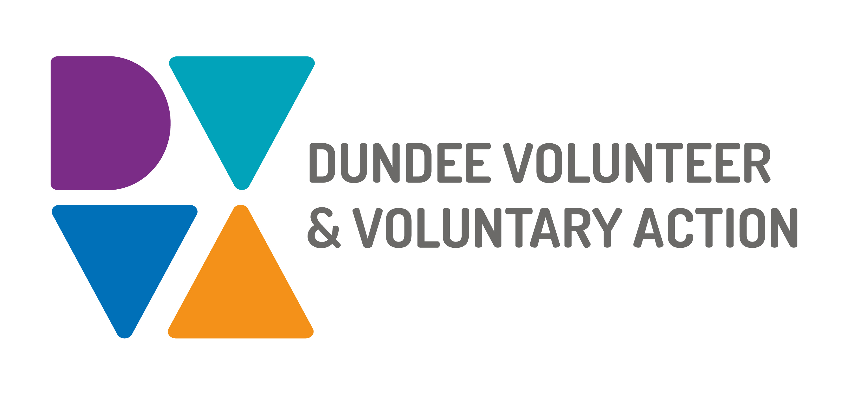
Job Description and
Person Specification

POST TITLE: Whitfield Community Hub Co-ordinator

DURATION: 12 months (in the first instance)

HOURS OF WORK: 35 hours per week, to be worked in accordance with DVVA Conditions of Service

SALARY: Grade 4 £27,278-£30,309

PURPOSE OF POST:
To assist in the development of the Community Hubs linking in with the funding outcomes providing a delivery centre for services based upon the needs of the community. The post holder will engage with other services around Dundee providing needs based services within the Hubs. The post holder will review the needs in the area regularly and communicate with the services involved through management meetings taking the lead in this. The Hub Co-ordinator will work in conjunction with Dundee City Councils community plan and in partnership with Dundee Alcohol and Drug Partnership.

MAIN DUTIES:

1. Establish, develop and facilitate a Hub Steering and User Involvement Group.

2. To have lead responsibility for the development of the Hub in partnership with the Hub steering group.

3. Ensure that the Hub has a welcoming community focussed ethos that encourages participation from all in the community.

4. Have knowledge of the community the Hub serves and create appropriate strategies to reduce barriers and promote participation from all within that community, particularly families and people affected by substance misuse, mental health, and poverty.

5. To gather data and evaluate data in line with agreed outcomes in order to provide regular reports to the steering group and Team Manager.

6. Undertaking face-to-face group work with adults and young people in the community to ascertain community need and aspirations.

7. Work in partnership with relevant providers and agencies to provide services appropriate to the needs of that community.

8. Assist in the development of smaller funding applications and initiatives, which create opportunities for the Hub with the aim of ensuring sustainability of the project.

9. Ensure that all Health and Safety Regulations and risk assessments are carried out according to guidelines.

GENERAL

• Contribute to quality assurance, which will ensure compliance with existing quality systems such as EFQM and Good Governance Award.
• Be aware of any areas of risk and advise on improvements
• Be committed to the work of DVVA and promote team working.
• Be committed to work of the Third Sector Interface and promote partnership working
• Work in accordance with the organisation’s policies and procedures

OTHER DUTIES
The job description is a broad picture of the post at the date of preparation. It is not an exhaustive list of all possible duties as it is recognised that jobs change over time. Should the duties change radically then the post and grading will be reviewed.

CONDITIONS OF SERVICE
- These are set out in the organisation’s staff handbook.
- All staff meeting the qualifying criteria may join a defined contribution pension scheme provided by TPT Retirement Solutions.
- The organisation has an equal opportunities policy and seeks to be an equal opportunities employer.

ANNUAL LEAVE: 21 days per annum on appointment increasing each year by 1 day to a maximum of 25 days, plus 6 public holidays, plus 5 days Christmas closedown. Pro-rata for part-time staff.

LOCATION: Whitfield Community Hub, 71 Lothian Crescent, Dundee and Lochee Hub, 118-120 High Street Dundee and any other location deemed necessary to fulfil the duties of the role. There may be an option for the post to be a blend of home and office working in future.

TRAINING: Staff may make application to pursue appropriate training.

JOB DESCRIPTIONS are reviewed from time to time.

Person Specification

ESSENTIAL | DESIRABLE
Community Learning & Development, Social Work or other appropriate qualification at degree level or 5 years’ experience. | Qualifications related to the fields of substance misuse, mental health & wellbeing, adult learning or child development.
Community Development experience | Knowledge/experience of co-production.  Managing physical resources or building management
Commitment to tackling inequalities caused by socio-economic disadvantage

Understanding of substance misuse, adult learning, mental health or child development issues. | Knowledge of recovery focussed approaches and child protection policy.
Understanding of the Third Sector and the environment in which it operates. | Experience of working at a senior level within the third sector

Understanding or willing to research environmentally friendly approaches and issues surrounding climate change.
Understanding of the work of the public sector in particularly local authorities and Health & Social Care | Developing and designing policies and procedures, risk assessments and service database
Monitoring, evaluation and report writing experience | Track record of making successful funding applications/ tenders or generating income streams
Excellent verbal and written communication skills | Managing HR requirements
The ability and track record of establishing and maintaining effective informal networking and multi-agency working | Training: First Aid / De-escalation / naloxone
Able to work independently and proactively with a minimum level of supervision | Outcome star trained for assessments and information collecting for funding purposes
Excellent organisation skills | Experience of supervising and supporting staff
IT literate – particularly use of Microsoft Office, e-mail, the internet and database systems
A personal commitment to equal opportunities displays honesty, integrity and a strong sense of ethics in all actions and decisions.
Satisfactory PVG check

