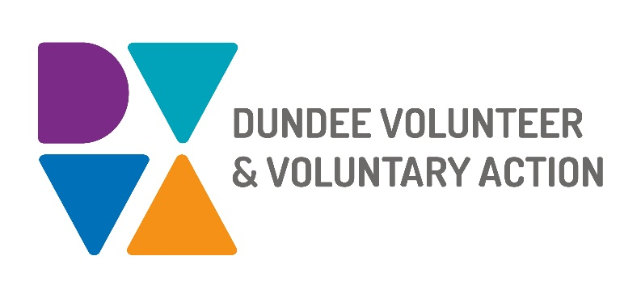
Job Description and
Person Specification

POST TITLE: Authentic Voices Project Manager

DURATION: 18 month fixed term contract

HOURS OF WORK: 28 hours per week, to be worked in accordance with DVVA Conditions of Service

SALARY: £30,363 - £33,737 (pro rata)

REPORTS TO: Lead Office, Protecting People Team, at Dundee Health and Social Care Partnership and DVVA Head of Service/Depute CEO

PURPOSE OF POST: We are seeking a passionate and dedicated Authentic Voices Project Manager to play a pivotal role in amplifying the voices and experiences of individuals with lived experience within strategic planning and decision-making forums. This will include an initial focus on the protecting people partnerships and committees. This position is instrumental in supporting a whole system culture shift in strategic spaces and ensuring that the needs, perspectives, and insights of the individuals we serve are authentically represented and integrated into the development and improvement of our programs and initiatives.

The post holder will be employed by Dundee Volunteer Voluntary Action and co-located to work as a member of the Protecting People Strategic Support Team (based within Dundee Health and Social Care Partnership).

PRINCIPAL WORKING CONTACTS
Individuals with lived experience, senior staff, and practitioners across all agencies - including Dundee City Council, NHS Tayside, Dundee Health and Social Care Partnership, National and Local Voluntary and Private Sector Organisations, Third Sector and Dundee Volunteer and Voluntary Action.

MAIN DUTIES:

- Take the Lead role in developing and supporting the Protecting People Authentic Voice Strategic Working group and implementation of the associated action plan.
- Support the implementation of the Alcohol and Drug Partnership Experiential Data collection program and support other protecting people committees to replicate the process through the Authentic Voice working group.
- Prepare project reports on progress on the recommendation and outcomes of the Dundee Authentic Voice Report and associated action plan.
- Identifying gaps in knowledge by understanding whose voices are not being amplified.
- Ensure any new activity doesn’t add to the burden of reporting and to existing data that is not currently analysed and actioned.
- Analyse qualitative data from people with lived experience to influence strategic planning.
- Establish effective links with Trauma Informed Approach and Gender Based Violence Learning and Development Coordinators, and the Gender Services Project Manager to develop co-working and joint initiatives.
- Build and maintain relationships with existing lived experience groups and communities to improve whole systems information gathering and strengthen feedback loops.
- Support committees/ partnerships and people with lived experience of trauma with co-design of meaningful and effective power sharing processes.
- Link with community groups and people with lived experience to create a bridge/link with protecting people strategic spaces.
- Establish partnerships with other organisations and individuals who share a commitment to the authentic voice principles.
- Develop and maintain meaningful relationships with all stakeholders including individuals with lives experience of trauma.
- Adapt to the needs, wishes and input of survivors and lived experience experts coming from an approach of non-discrimination and ability to create a safe space and empowerment for survivors from all backgrounds, and an individualised approach recognising that the requirements of some survivors/ individuals with lived experience to be able to do this work will be greater than others.
- Facilitate opportunities for people with lived experience and services and systems to engage in power sharing.
- Support people with lived experience to engage in strategic planning and decision-making processes.
- Amplify and coordinate authentic voices of individuals with lived experience across the partnership to influence decision-making.
- Provide feedback, communicate potential ways forward in a way that provides positive motivation for the audience and influences decision-making.
- Organise and facilitate workshops, seminars and conferences as required
- Work in accordance with our values, policies and procedures, including our equal opportunities and diversity framework

OTHER DUTIES
The job description is a broad picture of the post at the date of preparation. It is not an exhaustive list of all possible duties as it is recognised that jobs change over time. Should the duties change radically then the post and grading will be reviewed.

LIVED EXPERIENCE
We believe there is no ‘them and us’ in lived experiences of trauma and recognise that applicants may have direct or indirect experience of their own, whether disclosed or not. We are committed to placing lived experience at the heart of all we do, and colleagues who chose to share their personal expertise can do so openly and with organisational support. Any discussion during the recruitment process regarding a candidate's personal experiences of trauma, will be treated confidentially and will not be shared outside of the interview panel/Human Resources

CONDITIONS OF SERVICE
- These are set out in the organisation’s staff handbook.
- All staff meeting the qualifying criteria may join a defined contribution pension scheme provided by TPT Retirement Solutions.
- The organisation has an equal opportunities policy and seeks to be an equal opportunities employer.

ANNUAL LEAVE: 21 days per annum on appointment increasing each year by 1 day to a maximum of 25 days, plus 6 public holidays, plus 5 days Christmas closedown.

LOCATION: Working arrangements are in a hybrid style, based at home and at 5 City Square (Dundee Council), along with options for working within DVVA's Main office based in Dundee City Centre. The postholder may also be asked to work at any other location deemed necessary to fulfil the duties of the role.

TRAINING: Staff may make application to pursue appropriate training.

Person Specification

 | Essential | Desirable

Professional/Educational Qualifications
Degree or Post Graduate qualification in Social Work, Education, Community Education, Health or other equivalent qualification, or significant relevant experience | X
Degree plus post qualifying Certificate or Diploma in CLD or relevant subject |  | X
Knowledge and Experience
Experience working with diverse groups and communities | X
Experience delivering change programmes | X
Working knowledge of the lived experience landscape in Scotland and power sharing | X
Experience of strategic partnership working and collaboration | X
Working knowledge and understanding of the Voluntary Sector and the environment in which it operates | X
Knowledge of qualitative data analysis | X
Experience in Management role |  | X
Experience in project start up |  | X
Experience working in and knowledge of community development principles and best practices |  | X
Skills and Abilities
Excellent verbal and written communication skills | X
Ability to use own initiative and meet deadlines | X
Effective leader | X
Good presentation skills | X
Strong interpersonal and relationship building skills | X
A deep commitment to the principles of lived experience involvement and power sharing | X
IT/Web/PC competence |  | X
Ability to analyse and present management information |  | X
Excellent facilitation skills, with the ability to lead and resolve challenging or difficult conversations |  | X

Personal Qualities
Flexibility of approach | X
Honesty, reliability and authenticity | X
Ability to work as a team player | X
Empathy and compassion for others | X

Additional Job-Related requirements
A commitment to equal opportunities for all, tackling disadvantage and promoting diversity | X
Has a clean driving licence and or access to a car and driver | X
Satisfactory PVG check | X
Prepared to work hours according to the needs of the job | X

EMPLOYEE BENEFITS AT DVVA

Work/Life Balance
- Generous annual leave and public holidays, including 2 week shutdown over Christmas/New Year
- Increased annual leave entitlement based on length of employment
- Most roles are eligible to work flexibly, including hybrid options
- Right to request flexible working from day 1

You/Your Family
- Enhanced sick pay entitlement
- Increased sick pay entitlement based on length of employment
- Free access to a confidential 24 hours a day/7 days a week helpline service for you and your family with a specialist range of support and information, including access to coaching and counselling
- Discounted membership fees with Leisure and Culture Dundee for you and your family

Finances
- Generous pension contributions
- Access to voucher and discount schemes via Perks at Work
- Opportunity to join Discovery Credit Union and benefit from loans and savings at fair rates

Opportunities at Work
- Opportunities to undertake training relevant to your role and professional/personal development
- A lively and active Staff Consultation Group providing opportunities to influence how we work
- Recognition agreement with UNITE giving you legal support and much more
- Support for Wellbeing, including access to Wellbeing Champions

