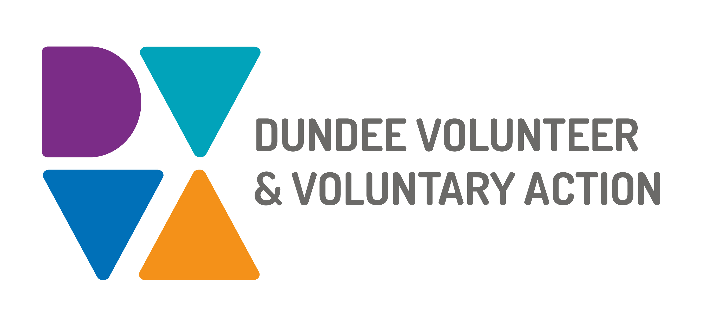
Job Description and
Person Specification

POST TITLE: Peer Recovery Development Worker (Mental Health)

DURATION: Permanent

HOURS OF WORK: 35 hours per week, to be worked in accordance with DVVA Conditions of Service

SALARY: Grade 3, £22,844 to £25,383

PURPOSE OF POST: Work as part of the Mental Health and Substance Use team to develop and enhance peer recovery initiatives in Dundee. In collaboration with partner organisations, you will develop capacity for and facilitate the growth of peer recovery practices to promote good mental health and wellbeing for all.
Develop and support the Dundee Peer Supporters Network.
Develop, promote, deliver, and facilitate access to learning and development opportunities for individuals with lived experience of mental health recovery.
Collaborate with others to develop, create, and sustain informal, voluntary and paid peer recovery roles within the field of mental health and wellbeing.

MAIN DUTIES:

- Promote, advocate for, and facilitate peer recovery to enable the citizens of Dundee to enjoy better mental health and wellbeing.

- Work to facilitate and support recovery story-sharing as a peer learning activity, promoting hope and optimism.

- Engage, encourage, and support organisations to develop and embed peer recovery opportunities and practices within their services, including informal peer support, volunteer roles, and paid positions.

- In collaboration with partner organisations deliver Peer to Peer and Creating Hope with Peer Support programmes, and work with individuals with lived experience to increase mental wellbeing training across the city.

Support Peer Recovery Practitioners

- Engage, encourage, and support people at all stages of recovery within a mental health context to participate in recovery-focused activities.

- Collaborate with partner organisations and peer recovery practitioners to develop, deliver, promote, and facilitate access to support peer recovery.

- Link with peer recovery initiatives in other sectors, such as substance use and suicide prevention, to maximise resources and reduce barriers for people affected by more than one condition.

- Appropriately record and gather evidence of the impacts of peer recovery on individuals, organisations, and communities.

- Develop and maintain relationships with peer recovery workers across the city, and create opportunities and events for them to network.

- Develop and support the Dundee Peer Supporters Network as a pool of experts by experience, a mechanism for mutual support, and a vehicle for the ongoing development of peer recovery in Dundee.

- Stay up to date with developments in peer recovery, sharing and building on good practice models and examples (through Scottish Recovery Network and the National Peer Practice Network).

Contribute to developing and delivering the Mental Health and Substance Use Team Plan

- Maintain accurate records of attendances, outputs and outcomes to evidence work undertaken.

- Actively and constructively participate in team meetings and activities.

- Work with team colleagues to ensure the plan and its delivery reflects the needs of individuals, organisations, and communities.

- Strive to maintain good practice in co-production.

General Duties

- Be committed to the work of Dundee Volunteer and Voluntary Action and promote team working.

- Work in accordance with our values, policies and procedures including our equal opportunities and diversity framework.

- Be committed to the work of the Third Sector Interface and promote partnership working.

- Undertake personal and professional development as required by the role.

OTHER DUTIES
The job description is a broad picture of the post at the date of preparation. It is not an exhaustive list of all possible duties as it is recognised that jobs change over time. Should the duties change radically then the post and grading will be reviewed.

CONDITIONS OF SERVICE
- These are set out in the organisation’s staff handbook.
- All staff meeting the qualifying criteria may join a defined contribution pension scheme provided by TPT Retirement Solutions.
- The organisation has an equal opportunities policy and seeks to be an equal opportunities employer.

ANNUAL LEAVE: 21 days per annum on appointment increasing each year by 1 day to a maximum of 25 days, plus 6 public holidays, plus 5 days Christmas closedown. Pro-rata for part-time staff.

LOCATION: The postholder will be based on site at our main office in Dundee city centre. They may also be asked to work at our community location in Lochee or any other location deemed necessary to fulfil the duties of the role.

WORKING HOURS: Our main office is currently open from 8.30am to 9pm, Monday to Thursday, and from 8.30am to 6pm on Friday. It is expected that the postholder will be able to work flexibly within these hours to ensure all aspects of the post are covered.

TRAINING: Staff may make application to pursue appropriate training.

Person Specification

 | Essential | Desirable

Professional/Educational Qualifications
Qualified to degree level or equivalent relevant experience. | X
Knowledge and Experience
Experience of cross-sector collaborative working, and delivering in multi-agency partnerships. | X
Working knowledge of mental health recovery, particularly peer recovery. | X
Experience of producing accurate records of work including plans, meeting notes and reports. | X
Working knowledge of the Health and Social Care Partnership. |  | X
Experience of organising recovery focused activities. |  | X
Experience of delivering training. |  | X
Experience of establishing and maintaining effective networks |  | X
Practical experience of the Third Sector and the environment in which it operates. |  | X

Skills and abilities
Excellent communication skills, both oral and written | X
Ability to independently and proactively plan, deliver and evaluate work. | X
Strong interpersonal skills, with the ability to manage professional relationships effectively. | X
Excellent organisational skills. | X
IT literate, particularly in use of Microsoft Office Packages. | X

Personal Qualities
Self-motivated, enthusiastic and committed. | X
Embodies Peer Values such as CHIME and HEARME. | X
Demonstrates patience and empathy. | X
Displays honesty, integrity and a strong sense of ethics in all actions and decisions. | X

Additional Job-Related requirements
Satisfactory PVG check. | X
Flexible working which may include evening and occasional weekend work. | X
Ability to move and work around Dundee easily and efficiently. | X

EMPLOYEE BENEFITS AT DVVA

Work/Life Balance
- Generous annual leave and public holidays, including 2 week shutdown over Christmas/New Year
- Increased annual leave entitlement based on length of employment
- Most roles are eligible to work flexibly, including hybrid options

You/Your Family
- Enhanced sick pay entitlement
- Increased sick pay entitlement based on length of employment
- Free access to a confidential 24 hours a day/7 days a week helpline service for you and your family with a specialist range of support and information, including access to coaching and counselling
- Discounted membership fees with Leisure and Culture Dundee for you and your family

Finances
- Generous pension contributions
- Access to voucher and discount schemes via Perks at Work
- Opportunity to join Discovery Credit Union and benefit from loans and savings at fair rates

Opportunities at Work
- Opportunities to undertake training relevant to your role and professional/personal development
- A lively and active Staff Consultation Group providing opportunities to influence how we work
- Recognition agreement with UNITE giving you legal support and much more
- Support for Wellbeing, including access to Wellbeing Champions

