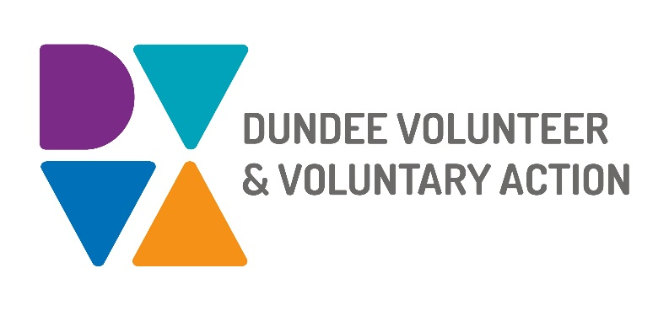

**Job Description and**

**Person Specification**

**POST TITLE: Volunteer Development Worker**

**DURATION: Fixed Term to 31st March 2026**

**HOURS OF WORK**: 21 hours per week, to be worked in accordance with DVVA Conditions of Service. Occasional evening and weekend work will be required.

**SALARY:** Grade 3 (£22,844 - £25,383 pro-rata)

**CONTEXT OF POST:** The post holder will be employed by DVVA and work on key areas for the development of a volunteer strategy for Dundee Children and Families services.

These services are deeply committed to fostering creativity, innovation and collaborative practices while actively pursuing the realisation of The Promise and Whole Family Support Principles.

They operate under the guidance and accountability of Dundee Children and family Services Planning Partnership. With an aim to enhancing the wellbeing of children and families in Dundee within their local communities whenever possible.

**PURPOSE OF POST:** To work with the Volunteer Manager on the creation, co design and implementation of the Children and Families Services Volunteer Strategy, collaborating closely with a wide array of partners and stakeholders to evaluate, refine and enact the Strategy.

**MAIN DUTIES:**

Enhanced governance and quality of volunteering opportunities for Children and Families

* To facilitate engagement of volunteers across various services, organisations and roles
* To investigate the development, and support the implementation of Volunteer Passports to streamline volunteer engagement and record skills and volunteer feedback on learning experiences
* To track the impact of volunteer involvement, both internally and externally
* Support organisations to use resources which allow for volunteers’ self-evaluation and to provide volunteers with methods for feedback.

Understanding gaps and barriers to diversity and inclusion of volunteers

* To maintain and add to detailed comprehensive mapping of volunteering within children and family services in Dundee.
* To conduct equality and diversity monitoring of volunteers within children and families services.
* To implement informed and targeted actions to recruit from different equality groups
* To explore innovative approaches to diversify volunteer opportunities
* To engage with partners to ensure an appealing and relevant approach for diverse communities

Recognising and valuing volunteers

* To prioritise volunteer satisfaction and engagement in meaningful activities
* To invest in volunteer development through training and skill sharing
* To investigate volunteer motivations and opportunities for volunteers to connect and celebrate.
* To demonstrate the significance of volunteering in service delivery and its multi-faceted advantages across communities.

General duties

* Demonstrate commitment to the work of DVVA and promote team working
* Demonstrate commitment to the work of Dundee’s Third Sector Interface (TSI) and promote partnership working
* Work in accordance with DVVA’s policies and procedures
* Identify any areas of risk and advise on improvements

# OTHER DUTIES

The job description is a broad picture of the post at the date of preparation. It is not an exhaustive list of all possible duties as it is recognised that jobs change over time. .

# CONDITIONS OF SERVICE

* These are set out in the organisation’s staff handbook.
* All staff meeting the qualifying criteria may join a defined contribution pension scheme provided by TPT Retirement Solutions.
* The organisation has an equal opportunities policy and seeks to be an equal opportunities employer.

**ANNUAL LEAVE:** 21 days per annum on appointment increasing each year by 1 day to a maximum of 25 days, plus 6 public holidays, plus 5 days Christmas closedown. Pro-rata for part-time staff.

**LOCATION:** Our main office is based in Dundee city centre and we also have a community hub in Lochee. There may be the opportunity for hybrid working depending on role and duties.

**TRAINING:** Staff may make application to pursue appropriate training.

**Person Specification**

## Volunteer Development Worker

## 

|  |  |  |
| --- | --- | --- |
|  | **Essential** | **Desirable** |
| Professional/Educational Qualifications |  |  |
| Relevant qualification such as Social Services, CLD/ Community Education or equivalent professional or volunteer experience. | Yes |  |
| Good IT skills and a strong knowledge of Office 365 | Yes |  |
| **Knowledge and Experience** |  |  |
| Knowledge of the ethos of the voluntary and community sectors | Yes |  |
| Experience of developing projects and initiatives | Yes |  |
| Establishing and maintaining effective working relationships. | Yes |  |
| Successful track record in community development | Yes |  |
| A sound knowledge of how the voluntary, statutory and community sectors work and a proven ability to build productive networks | Yes |  |
| A good understanding of how to work in an outcomes focused way | Yes |  |
| Design, delivery and evaluation of information, training sessions/ workshops | Yes |  |
| A good understanding of equality and diversity issues and a commitment to supporting people from marginalised groups | Yes |  |
| Experience of working with volunteers | Yes |  |
| Skills and abilities |  |  |
| Excellent communication skills, both oral and written | Yes |  |
| Excellent organisational skills with the ability to handle multiple tasks simultaneously | Yes |  |
| Ability to confidently build and maintain relationships with a diverse range of individuals and partner agencies. | Yes |  |
| Strong interpersonal skills, with the ability to manage internal and external relationships effectively | Yes |  |
| Project planning, delivery, monitoring and evaluation | Yes |  |
| Ability to motivate others | Yes |  |
| Ability to maintain an objective and professional perspective at all times | Yes |  |
| Personal Qualities |  |  |
| Self-motivated, enthusiastic and committed | Yes |  |
| Resilient, resourceful and flexible | Yes |  |
| Flexible approach with an ability to meet deadlines | Yes |  |
| Additional Job-Related requirements |  |  |
| Satisfactory PVG check | Yes |  |
| Flexible working which may include evening and occasional weekend work | Yes |  |
| Driving license |  | Yes |

**EMPLOYEE BENEFITS AT DVVA**

**Work/Life Balance**

Generous annual leave and public holidays, including 2 week shutdown over Christmas/New Year

Increased annual leave entitlement based on length of employment

Most roles are eligible to work flexibly, including hybrid options

**You/Your Family**

Enhanced sick pay entitlement

Increased sick pay entitlement based on length of employment

Free access to a confidential 24 hours a day/7 days a week helpline service for you and your family with a specialist range of support and information, including access to coaching and counselling

Discounted membership fees with Leisure and Culture Dundee for you and your family

**Finances**

Generous pension contributions

Access to voucher and discount schemes via Perks at Work

Opportunity to join Discovery Credit Union and benefit from loans and savings at fair rates

**Opportunities at Work**

Opportunities to undertake training relevant to your role and professional/personal development

A lively and active Staff Consultation Group providing opportunities to influence how we work

Recognition agreement with UNITE giving you legal support and much more

Support for Wellbeing, including access to Wellbeing Champions