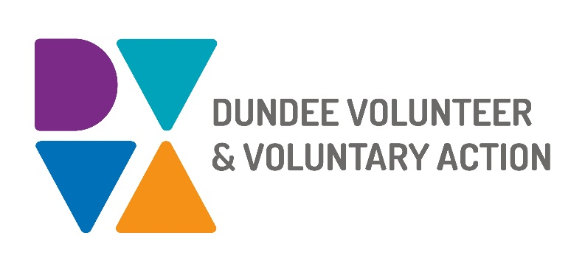

**Job Description and**

**Person Specification**

**POST TITLE: Volunteering and Community Development Worker (Communities Team)**

**DURATION:** Permanent, subject to initial 6 months probationary period

**HOURS OF WORK**: 35 hours per week, to be worked in accordance with DVVA Conditions of Service. Occasional evening and weekend work will be required.

**SALARY:** Grade 3 (£22,844 - £25,383 pro-rata)

**CONTEXT OF POST:** The post holder will be employed by DVVA and work on key areas for supporting individuals and communities to develop and thrive.

This role is funded by the Dundee Health and Social Care Partnership, and will respond to key issues identified by communities, local partners, helping to address local and national agreed priorities.

**PURPOSE OF POST:** To work with Dundee communities, promoting and encouraging volunteering, and supporting interventions that facilitate positive change across communities. This role contributes to establishing a more resilient and sustainable Third Sector in Dundee through the provision of inclusive volunteering, organisational guidance, training opportunities and evidence-based interventions.

**MAIN DUTIES:**

**Volunteering**

* Provide one-to-one or group support in relation to volunteer enquiries
* Develop resources that are up to date and engaging for identified target audiences
* Identify barriers to volunteering and implement strategies to overcome these
* Promote volunteering and the benefits to individuals and groups by a variety of means, including community events, delivering information sessions and online sessions
* Create positive working relationships with organisations where there is potential for people to gain new skills, lead to employment, and give back to the community

**Community engagement**

* Develop effective working relationships with community workers, key organisations and communities to promote involvement and coordinated models of working across Dundee
* Engage with communities and key partners through consultations, and awareness, learning and training events
* Liaise with communities and partners to assess needs, including issues identified by community planning partners, and contribute to collective action

**Organisational Development and Capacity Building**

* Provide opportunities for communities to develop their own capacity and enable

them to create positive and sustainable change, based on models of good practice and coproduction

* In coproduction with communities and key partners, develop and support new areas of work and/or opportunities, leading to enhanced service provision
* Contribute to the development and delivery of networking, learning and development opportunities to help organisations and groups adhere to good practice standards
* Provide guidance on best practice and signpost to funding opportunities

# Contribute to the development, delivery and evaluation of DVVA’s Communities Team work

# Identify and report issues and “knowledge gaps” amongst volunteers, volunteer-involving organisations and communities

# Undertake monitoring requirements, report against outcomes and provide service updates as required

# Collaborate with colleagues from the Communities Team to contribute to service developments and meet shared outcomes

**General duties**

* Demonstrate commitment to the work of DVVA and promote team working
* Demonstrate commitment to the work of Dundee’s Third Sector Interface (TSI) and promote partnership working
* Work in accordance with DVVA’s policies and procedures

# OTHER DUTIES

The job description is a broad picture of the post at the date of preparation. It is not an exhaustive list of all possible duties as it is recognised that jobs change over time.

# CONDITIONS OF SERVICE

* These are set out in the organisation’s staff handbook.
* All staff meeting the qualifying criteria may join a defined contribution pension scheme provided by TPT Retirement Solutions.
* The organisation has an equal opportunities policy and seeks to be an equal opportunities employer.

**ANNUAL LEAVE:** 21 days per annum on appointment increasing each year by 1 day to a maximum of 25 days, plus 6 public holidays, plus 5 days Christmas closedown. Pro-rata for part-time staff.

**LOCATION:** Our main office is based in Dundee city centre and we also have a community hub in Lochee. There may be the opportunity for hybrid working depending on role and duties.

**TRAINING:** Staff may make application to pursue appropriate training.

**Person Specification**

|  |  |  |
| --- | --- | --- |
|  | **Essential** | **Desirable** |
| Professional/Educational Qualifications |  |  |
| Relevant qualification such as Social Services, CLD/ Community Education or equivalent professional or volunteer experience. | Yes |  |
| **Knowledge and Experience** |  |  |
| Knowledge of the ethos of the voluntary and community sectors | Yes |  |
| Local priorities and issues faced by communities/ individuals | Yes |  |
| Health inequalities | Yes |  |
| Establishing and maintaining effective working relationships | Yes |  |
| Successful track record in engagement and community development | Yes |  |
| Social inclusion and equality | Yes |  |
| Development work with voluntary and community groups | Yes |  |
| Cross-sector collaboration | Yes |  |
| People-led and asset-based approach | Yes |  |
| Creation, delivery/facilitation and evaluation of awareness/information/training sessions |  | Yes |
| Skills and abilities |  |  |
| Excellent communication skills, both oral and written | Yes |  |
| Excellent organisational skills with the ability to handle multiple tasks simultaneously | Yes |  |
| Strong interpersonal skills, with the ability to manage internal and external relationships effectively | Yes |  |
| Project planning, target setting, monitoring and evaluation | Yes |  |
| Networking and partnership work | Yes |  |
| Ability to engage with a wide range of stakeholders | Yes |  |

|  |  |  |
| --- | --- | --- |
| Ability to identify needs of specific groups | Yes |  |
| Ability to work within a team as well as on own initiative | Yes |  |
| Ability to organise and manage resources | Yes |  |
| Ability to research, identify and  develop volunteering opportunities | Yes |  |
| Ability to motivate others | Yes |  |
| Personal Qualities |  |  |
| Self-motivated, enthusiastic and committed | Yes |  |
| Flexible approach with an ability to meet deadlines | Yes |  |
| Open-minded, resourceful, creative and innovative | Yes |  |
| Additional Job-Related requirements |  |  |
| Satisfactory PVG check | Yes |  |
| Flexible working which may include evening and occasional weekend work | Yes |  |
| Driving Licence and access to a car |  | Yes |

**EMPLOYEE BENEFITS AT DVVA**

**Work/Life Balance**

Generous annual leave and public holidays, including 2 week shutdown over Christmas/New Year

Increased annual leave entitlement based on length of employment

Most roles are eligible to work flexibly, including hybrid options

**You/Your Family**

Enhanced sick pay entitlement

Increased sick pay entitlement based on length of employment

Free access to a confidential 24 hours a day/7 days a week helpline service for you and your family with a specialist range of support and information, including access to coaching and counselling

Discounted membership fees with Leisure and Culture Dundee for you and your family

**Finances**

Generous pension contributions

Access to voucher and discount schemes via Perks at Work

Opportunity to join Discovery Credit Union and benefit from loans and savings at fair rates

**Opportunities at Work**

Opportunities to undertake training relevant to your role and professional/personal development

A lively and active Staff Consultation Group providing opportunities to influence how we work

Recognition agreement with UNITE giving you legal support and more

Support for Wellbeing, including access to Wellbeing Champions