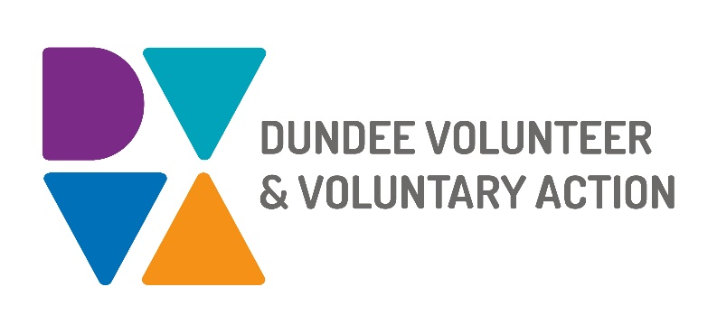

**Job Description and**

**Person Specification**

**POST TITLE: Volunteer Development Worker**

**DURATION: Fixed Term to 31st March 2026**

**HOURS OF WORK**: 21 hours per week, to be worked in accordance with DVVA Conditions of Service. Occasional evening and weekend work will be required.

**SALARY:** Grade 3 (£22,844 pro-rata)

**PURPOSE OF POST:** To work with the Volunteer Manager on the creation, co-design and implementation of the Children and Families Services Volunteer Strategy. To work collaboratively with organisations and groups to explore volunteer passport options and co-develop a bespoke model.

To engage widely with partners, communities, families and volunteers to gather views on how children and families services can be enhanced through volunteering.

**CONTEXT OF POST:** The post holder will be employed by DVVA and work

on key areas for the development of a volunteer strategy for Dundee Children and Families services. These services are guided by the principles of both [The Promise](https://thepromise.scot/) and [Whole Family Support,](https://www.gov.scot/publications/routemap-national-principles-holistic-whole-family-support/) to enhance the wellbeing of children and families in Dundee.

**MAIN DUTIES:**

To enhance governance and quality of volunteering opportunities for Children and Families

* To develop and support the implementation of Volunteer Passports in order to simplify processes and make volunteering more accessible and attractive
* To engage with volunteers across various services to ensure that their voice shapes developments
* To measure the impact of volunteer involvement for families, services and the volunteers themselves
* Support organisations to use resources which allow for volunteers’ development, self-evaluation and reflection

To understand gaps and barriers to diversity and inclusion of volunteers

* To contribute to the mapping of volunteering within children and family services in Dundee
* To plan engagement based on the findings of equality and diversity of volunteers within children and families services
* To implement informed and targeted actions to recruit from different equality groups
* To explore innovative approaches to diversify volunteer opportunities

To recognise and value volunteers

* To prioritise volunteer satisfaction and engagement in meaningful activities
* To invest in volunteer development through training and skill sharing
* To find out volunteer motivations and opportunities for volunteers to connect and celebrate
* To demonstrate the significance of volunteering in service delivery and its advantages across communities

General duties

* Demonstrate commitment to the work of DVVA and promote team working
* Demonstrate commitment to the work of Dundee’s Third Sector Interface (TSI) and promote partnership working
* Work in accordance with DVVA’s policies and procedures
* Identify any areas of risk and advise on improvements

# OTHER DUTIES

The job description is a broad picture of the post at the date of preparation. It is not an exhaustive list of all possible duties as it is recognised that jobs change over time.

# CONDITIONS OF SERVICE

* These are set out in the organisation’s staff handbook.
* All staff meeting the qualifying criteria may join a defined contribution pension scheme provided by TPT Retirement Solutions.
* The organisation has an equal opportunities policy and seeks to be an equal opportunities employer.

**ANNUAL LEAVE:** 21 days per annum on appointment increasing each year by 1 day to a maximum of 25 days, plus 6 public holidays, plus 5 days Christmas closedown. Pro-rata for part-time staff.

**LOCATION:** Our main office is based in Dundee city centre, and we also have a community hub in Lochee. There may be the opportunity for hybrid working depending on role and duties.

**TRAINING:** Staff may make application to pursue appropriate training.

**Person Specification**

## Volunteer Development Worker

## 

|  |  |  |
| --- | --- | --- |
|  | **Essential** | **Desirable** |
| Professional/Educational Qualifications |  |  |
| Relevant qualification such as Social Services, CLD/ Community Education or equivalent professional or volunteer experience. | Yes |  |
| Good IT skills and a strong knowledge of Office 365 | Yes |  |
| **Knowledge and Experience** |  |  |
| Knowledge of the ethos of the voluntary and community sectors | Yes |  |
| Experience of planning initiatives and developing projects | Yes |  |
| Establishing and maintaining effective working relationships. | Yes |  |
| Successful track record in community development | Yes |  |
| A sound knowledge of how the voluntary, statutory and community sectors work and a proven ability to build productive networks |  | Yes |
| A good understanding of how to work in an outcomes focused way | Yes |  |
| Design, delivery and evaluation of information, training sessions/ workshops | Yes |  |
| A good understanding of equality and diversity issues and a commitment to supporting people from marginalised groups | Yes |  |
| Experience of working with volunteers | Yes |  |
| Skills and abilities |  |  |
| Excellent communication skills, both oral and written | Yes |  |
| Excellent organisational skills with the ability to handle multiple tasks simultaneously | Yes |  |
| Ability to confidently build and maintain relationships with a diverse range of individuals and partner agencies. | Yes |  |
| Strong interpersonal skills, with the ability to manage internal and external relationships effectively | Yes |  |
|  |  |  |
| Ability to motivate others | Yes |  |
| Ability to maintain an objective and professional perspective at all times | Yes |  |
| Personal Qualities |  |  |
| Self-motivated, enthusiastic and committed | Yes |  |
| Resilient, resourceful and flexible | Yes |  |
| Ability to meet deadlines | Yes |  |
| Additional Job-Related requirements |  |  |
| Satisfactory PVG check | Yes |  |
| Flexible working which may include evening and occasional weekend work |  | Yes |
| Driving license |  | Yes |

**EMPLOYEE BENEFITS AT DVVA**

**Work/Life Balance**

Generous annual leave and public holidays, including 2 week shutdown over Christmas/New Year

Increased annual leave entitlement based on length of employment

Most roles are eligible to work flexibly, including hybrid options

**You/Your Family**

Enhanced sick pay entitlement

Increased sick pay entitlement based on length of employment

Free access to a confidential 24 hours a day/7 days a week helpline service for you and your family with a specialist range of support and information, including access to coaching and counselling

Discounted membership fees with Leisure and Culture Dundee for you and your family

**Finances**

Generous pension contributions

Access to voucher and discount schemes via Perks at Work

Opportunity to join Discovery Credit Union and benefit from loans and savings at fair rates

**Opportunities at Work**

Opportunities to undertake training relevant to your role and professional/personal development

A lively and active Staff Consultation Group providing opportunities to influence how we work

Recognition agreement with UNITE giving you legal support and much more

Support for Wellbeing, including access to Wellbeing Champions