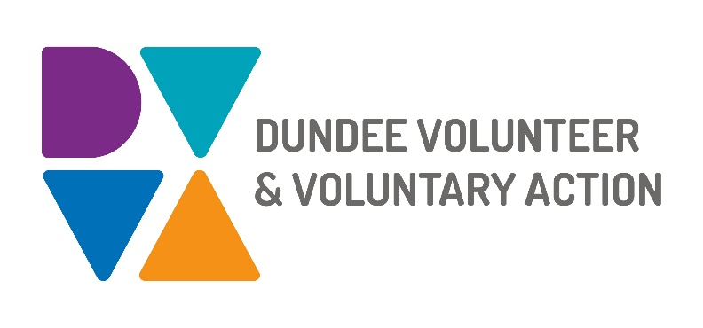

**Job Description and**

**Person Specification**

**POST TITLE: Community Mental Health and Wellbeing Fund Support Worker**

**DURATION:** Fixed Term, 10 months

**HOURS OF WORK**: 28 hours per week, to be worked in accordance with DVVA Conditions of Service

**SALARY:** Grade 3 - £22,844 to £25,383 (pro-rata)

**BACKGROUND AND PURPOSE OF POST**

The Communities Mental Health and Wellbeing Fund for Adults, established in October 2021, is a Scottish Government fund administered by the local Third Sector Interfaces. In Dundee, Dundee Volunteer and Voluntary Action (DVVA) manages and distributes the fund to community initiatives and organisations which build community resilience, tackle mental health inequalities and/ or social isolation.

With a strong focus on prevention and early intervention, the fund aims to support grassroots groups and Third Sector organisations to deliver projects that meet the funding criteria and address local priorities.

The successful candidate will be part of a small team within DVVA which is responsible for the efficient management and successful distribution of the Communities Mental Health and Wellbeing Fund for Adults. Key to this role is supporting the coordination, development, implementation, monitoring and reporting of the Fund.

**MAIN DUTIES:**

**Fund support**

* Process, log and save applications, following internal procedures and protocols.
* Ensure that applications are promptly acknowledged.
* Respond to enquiries constructively, efficiently and within established timelines.
* Liaise and communicate with applicants, and support them through the course of the application process.
* Provide information to applicants in relation to the fund criteria, application process, and outcome of assessments.
* Produce grant letters and efficiently communicate assessment outcomes to applicants.
* Support with the coordination of processing payments to awardees.
* Support the coordination of Fund Assessment Panel and Oversight Group meetings, collating the necessary information and maintaining effective communication with decision-making partners.

**Quality assurance**

* Adhere to a planned timeline of activities and associated tasks, including the launch of the fund, submission of applications, panel deliberations, award letters, monitoring and reporting requirements.
* Follow internal processes and procedures to process applications and communicate with groups and organisations.
* Support the involvement of people with lived experience, in a way that their contributions also inform the decision-making process.

**Organisational Development and Capacity Building**

* Support organisations to submit suitable project proposals and funding bids that comply with the fund requirements and align with strategic priorities.
* With guidance from the Team, assist organisations to have the best chances of securing funding, providing feedback and encouraging resubmissions where relevant.
* Identify incomplete applications and liaise with applicants to support the submission of bids within established deadlines.

**Engagement and communications**

* To produce promotional materials that raise awareness of the fund.
* To undertake a multi-channel approach which ensures that the information is understood and received by a broad audience.
* To organise and deliver information sessions, attend meetings and events to increase the visibility of the fund and identify eligible community-led initiatives.
* Ensure funding updates are effectively communicated through digital channels and also in-person engagement

**Reporting and Evaluation**

* Support the monitoring, reporting and evaluation of funded projects and collate reports to the Scottish Government.
* Gather learning and suggest ways of improving internal and external processes in the future.

# OTHER DUTIES

The job description is a broad picture of the post at the date of preparation. It is not an exhaustive list of all possible duties as it is recognised that jobs change over time. Should the duties change radically then the post and grading will be reviewed.

# CONDITIONS OF SERVICE

* These are set out in the organisation’s staff handbook.
* All staff meeting the qualifying criteria may join a defined contribution pension scheme provided by TPT Retirement Solutions.
* The organisation has an equal opportunities policy and seeks to be an equal opportunities employer.

**ANNUAL LEAVE:** 21 days per annum on appointment increasing each year by 1 day to a maximum of 25 days, plus 6 public holidays, plus 5 days Christmas closedown.

**LOCATION:** Our main office is based in Dundee city centre and we also have a community location in Lochee.

**TRAINING:** Staff may make an application to pursue appropriate training.

**JOB DESCRIPTIONS** are reviewed from time to time.

**Person Specification**

|  |  |  |
| --- | --- | --- |
|  | **Essential** | **Desirable** |
| Professional/Educational Qualifications |  |  |
| Qualified to degree level on relevant discipline or minimum 3 years relevant experience | **🗸** |  |
| Other relevant qualifications e.g. project management, or business/voluntary sector management |  | **🗸** |
| **Knowledge and Experience** |  |  |
| Understanding of developing and writing successful funding bids |  | **🗸** |
| Knowledge of the Third Sector | **🗸** |  |
| Experience of working/volunteering within the Third Sector | **🗸** |  |
| Establishing and maintaining effective working relationships | **🗸** |  |
| Community engagement | **🗸** |  |
| Community development and capacity building |  | **🗸** |
| Planning, target setting, monitoring and evaluation | **🗸** |  |
| Knowledge of relevant local/ national strategies, policies and/or funding programmes |  | **🗸** |
| Skills and abilities |  |  |
| Exceptional attention to detail, ensuring accuracy and thoroughness with all admin and communication tasks | **🗸** |  |
| Excellent communication skills, both oral and written | **🗸** |  |
| Confident team member, who demonstrates self-assurance and takes initiative | **🗸** |  |
| Proven ability to relate to a wide range of people and organisations from Third Sector organisations and voluntary groups |  | **🗸** |
| Excellent organisational skills with the ability to handle multiple tasks simultaneously | **🗸** |  |
| Networking and collaboration work | **🗸** |  |
| Advanced IT skills, including in the use of Microsoft Office packages | **🗸** |  |
| Project management skills including planning, delivery, monitoring and evaluation |  | **🗸** |
| Ability to use recognised methods to monitor and evaluate outcomes |  | **🗸** |
| Problem-solving skills | **🗸** |  |
| Personal Qualities |  |  |
| Self-motivated, enthusiastic and committed | **🗸** |  |
| Adaptable and resourceful | **🗸** |  |
| Flexible approach with an ability to meet deadlines | **🗸** |  |
| A commitment to equal opportunities for all, tackling disadvantage and promoting diversity | **🗸** |  |
| Additional Job-Related requirements |  |  |
| Satisfactory Basic Disclosure check | **🗸** |  |
| Flexible working which may include evening and occasional weekend work | **🗸** |  |

**EMPLOYEE BENEFITS AT DVVA**

**Work/Life Balance**

* Generous annual leave and public holidays, including 2-week shutdown over Christmas/New Year
* Increased annual leave entitlement based on length of employment
* Most roles are eligible to work flexibly, including hybrid options
* Right to request flexible working from day 1

**You/Your Family**

* Enhanced sick pay entitlement
* Increased sick pay entitlement based on length of employment
* Free access to a confidential 24 hours a day/7 days a week helpline service for you and your family with a specialist range of support and information, including access to coaching and counselling
* Discounted membership fees with Leisure and Culture Dundee for you and your family

**Finances**

* Generous pension contributions
* Access to voucher and discount schemes via Perks at Work
* Opportunity to join Discovery Credit Union and benefit from loans and savings at fair rates

**Opportunities at Work**

* Opportunities to undertake training relevant to your role and professional/personal development
* A lively and active Staff Consultation Group providing opportunities to influence how we work
* Recognition agreement with UNITE giving you legal support and much more
* Support for Wellbeing, including access to Wellbeing Champions