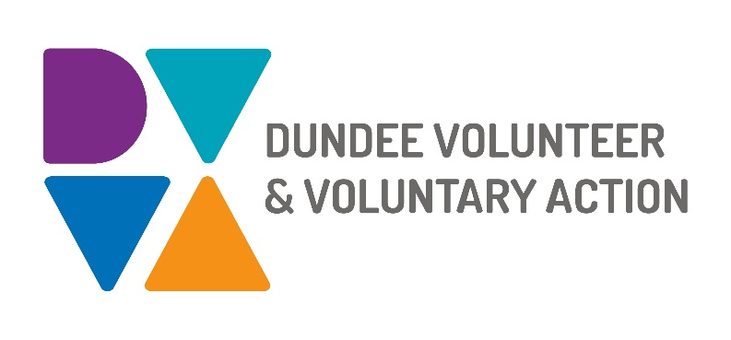
Job Description and
Person Specification

POST TITLE: Receptionist

DURATION: Sessional

HOURS OF WORK: Sessional hours offered to cover holidays and absence to be worked in accordance with DVVA Conditions of Service. Hours are regularly available both daytime and evenings.

SALARY: £15.07 per hour (This hourly rate is inclusive of annual leave entitlement of 12.07%)

PURPOSE OF POST: To provide, as part of a team, an efficient, effective and high-level reception service to staff, tenants and members of the public.

MAIN DUTIES:

- Welcome visitors to Number Ten, notifying appropriate organisations of their arrival
- Maintain a record of staff and visitors’ entry and exit from the building
- Answer telephone calls to the building and take messages or redirect as appropriate
- Assist in maintaining a booking system for all meeting rooms, and dealing with payments as necessary
- Prepare meeting rooms to the requirement of users including moving tables and chairs and setting up refreshments and equipment
- Assist in keeping display and information materials in the reception area in good order
- Report any property maintenance issues or defects
- Manage DVVA’s equipment loan service, including promotion and bookings, ensuring all resources are appropriately managed, logged and accounted for.
- Undertake clerical duties relevant to the post including handling petty cash
- Ensure security of building and authorised usage of the car park
- Ensure compliance with Health & Safety Regulations
- Be a standby key holder for the building.

OTHER DUTIES
The job description is a broad picture of the post at the date of preparation. It is not an exhaustive list of all possible duties as it is recognised that jobs change over time. Should the duties change radically then the post and grading will be reviewed.

CONDITIONS OF SERVICE
- These are set out in the organisation’s staff handbook.
- All staff meeting the qualifying criteria may join a defined contribution pension scheme provided by TPT Retirement Solutions.
- The organisation has an equal opportunities policy and seeks to be an equal opportunities employer.

LOCATION: You will be based at our main office in Dundee city centre.

TRAINING: Staff may make application to pursue appropriate training.

JOB DESCRIPTIONS are reviewed from time to time.

Person Specification

Sessional Receptionist

 | Essential | Desirable

Professional/Educational Qualifications
Education to school leaving certificate level or equivalent (3 National 5/Standard/O Grades) |  | X
Knowledge and Experience
Working in an office environment | X
Reception duties and responsibilities |  | X
Dealing with the public and general enquiries | X

Skills and abilities
Excellent oral and written communication skills | X
Effective interpersonal skills | X
IT skills, including the use of Microsoft Office | X
Ability to handle difficult situations |  | X
Ability to undertake physical work such as moving tables and chairs |  | X

Personal Qualities
Self-motivated, enthusiastic and committed | X

Additional Job-Related requirements
Satisfactory references | X
Flexible working – Able to work flexibly as required to provide cover for holidays and absence | X
Standard disclosure check | X
First Aid training once in post | X
Fire Warden training once in post | X

